*Akademija tehničko-umetničkih strukovnih studija Beograd,   
Odsek Visoka škola za informacione i komunikacione tehnologije*

[*https://cirictamara.github.io/Moolens-Store/*](https://cirictamara.github.io/Moolens-Store/)

*Dokumentacija za predispitni sajt iz predmeta Web programiranje 1*

*Smer: Internet tehnologije*

*Modul: Web programiranje*

*Profesor: Milena Čančarević Student: Tamara Ćirić 27/20*

*Beograd, februar 2022.*

# *Sadržaj*

Sadržaj 2

1. Uvod 3

*1.1 Korišćeni programski jezici 3*

*1.2 Opis funkcionalnosti 3*

*1.3 Template 4*

2. Organizacija 5

*2.1 Organizaciona šema 5*

*2.2 Mapa sajta 5*

*2.3 Slike stranica i opisi funkcionalnosti 5*

*2.3.1 index.html 5*

*2.3.2 https://cirictamara.github.io/portfolio/ 13*

3. Kodovi 15

*3.1 HTML 15*

*3.1.1 index.html 15*

*3.2 CSS 17*

*3.2.1 style.css 17*

*3.2.2 responsive.css 28*

*3.3 JavaScript 44*

*3.3.1 main.js 44*

*3.4 jQuery Plugin 72*

*3.4.1 scroll-to-top.js 72*

# *1. Uvod*

## *1.1 Korišćeni programski jezici*

*Za izradu sajta korišćene su sledeće tehnologije:*

1. ***Bootstrap v4.5*** *– besplatni web framework otvorenog koda namenjen za kreiranje web sajtova*

*i web aplikacija, baziran na HTML i CSS šablonima,*

1. ***CSS*** *(Cascading Style Sheets) – jezik formatiranja pomoću kog se definiše izgled elemenata web*

*stranice,*

1. ***HTML*** *(HyperText Markup Language) – opisni jezik specijalno namenjen opisu web stranica,*
2. ***JavaScript*** *– dinamičan, slabo tipiziran i interpretiran programski jezik višeg nivoa,*
3. ***jQuery*** *– višeplatformska JavaScript biblioteka,*
4. ***jQuery Plugin*** *– metod koji se koristi za proširenje jQuery prototipa objekta,*
5. ***XML*** *(Extensible Markup Language) – standardni skup pravila za definisanje formata podataka   
   u elektronskoj formi.*

*Svi navedeni jezici, biblioteke i framework-ovi pisani su unutar ,,Visual Studio Code“ okruženja.*

## *1.2 Opis funkcionalnosti*

* *Kratka animacija prilikom učitavanja web stranice, nakon koje korisnik nesmetano može da pregleda web stranicu i izvršava različite zahteve.*
* *Progress bar u podnožju prozora uređaja koji grafički prikazuje koji procenat pregledanog sadržaja web stranice.*
* *Dinamički kreirano zaglavlje web stranice (logo i navigacioni meni) uz dodatne funkcionalnosti prilikom scroll-ovanja web stranice: promena stanja aktivnog linka kada se dođe do odgovarajuće glavne sekcije, kao i promena izgleda samog zaglavlja.*
* *Dinamički kreiran slider od 3 elementa, uz dodeljene sledeće funkcionalnosti: (1) automatska promena sadržaja na svakih 5 sekundi koja se zaustavlja onoliko dugo koliko se kursor miša nalazi na samom elementu i (2) promena sadržaja u skladu sa klikom na odgovarajuću strelicu: prethodni element (‹), sledeći element (›).*
* *Dinamički ispisana sekcija sa 2 tekstualna elementa i 4 elementa sa pozadinskom slikom. Svakom elementu sa pozadinskom sikom dodeljena je jednostavna zoom animacija koja se aktivira prelaskom kursora miša preko samog elementa.*
* *Dinamički ispisana sekcija „About Moolen’s“ uz dodatnu funkcionalnost prikazivanja (klikom na tekst „Our Story“) i zatvaranja modala (klikom na ikonicu* ✕*).*
* *Dinamički kreirana galerija slika u kojoj je po default-u proširen prvi element i prikazan njegov sadržaj, dok su ostali elementi skupljeni. Svakom elementu je dodeljena mogućnost promene prelaksom kursora miša preko samog elementa, kada on postaje aktivni (prošireni) element. Onog trenutka kada kursor miša izađe iz okvira sekcije „Galley“, sekcija se vraća u svoj podrazumevani izgled (prvi element proširen, dok su ostali skupljeni). Funkcionalnost je prilagođena za dve prelomne tačke: (min-width: 900px) i (max-width: 899px).*
* *Dinamički ispisana sekcija „Services“.*
* *Dinamički ispisana sekcija sa automatskim brojačima. U okviru svakog brojača, elementu koji u svom value atributu čuva informaciju o broju koji treba da se ispiše, dodeljena je animacija automatskog inkrementiranja za određenu vrednost. Onog trenutka kada korisnik dođe do tačke gde je sekcija u vidnom polju, sve animacije se aktiviraju i izvršavaju istovremeno.*
* *Dinamički kreirana kontakt forma koja sadrži sledeće elemente: polje za ime i prezime, polje za e-mail adresu, drop down listu, polje za datum, polje za vreme, polje za unos poruke i dugme za submit-ovanje. Obazezna su sledeća polja: polje za ime i prezime, polje za e-mail adresu i polje za unos poruke.*

*Ukoliko korisnik želi da zakaže posetu nekoj od preporučenih prodavnica ili pak zakaže razgovor može iz opcione drop down liste izabrati najbliži objekat, nakon čega se otvara mogućnost izbora datuma. Kada korisnik izabere datum, otvara se mogućnost biranja termina. Jednom kada korisnik izabere neku stavku iz drop down liste, sva polja se smatraju obaveznim, u suprotnom obavezna su samo gore napomenuta polja.*

*Nakon promene stanja polja, korisniku se ispisuje poruka da li je uneti sadržaj ispravno formatiran ili ne. Za ime i prezime, kao i za e-mail adresu format se proverava na osnovu regularnog izraza, dok se za poruku smatra da je polje ispravno popunjeno ukoliko je unet bar jedan karakter. Polja za datum i vreme validiraju se u zavisnosti od radnih dana i ranih sati objekata.*

*Ukoliko je korisnik popunio bar polje za datum, a potom promeni izbor opcije iz padajuće liste, tada se izabrane vrednosti u poljima za datum i vreme poništavaju i polje za vreme opet postaje nedostupno za unos dok korisnik ne izabere datum. Ukoliko korisnik pak izabere nultu opciju tj. podrazumevani tekst oba polja postaju nedostupna za unos.*

*Ukoliko korisnik želi da submit-uje formu koja nije ispravno popunjena, taj zahtev će se odbiti tj. ništa se neće dogoditi. Ukoliko korisnik submit-uje praznu formu, to takođe neće biti moguće, ali u ovom slučaju neće biti prikazane greške (prikazuju se samo kada se stanje nekog polja promeni, a u kontekstu punog termina tek nakon sto se i polje za datum i polje za vreme popune).*

* *Dinamički ispisano podnožje web stranice.*
* *Dugme za povratak na vrh web stranice je urađreno preko jQuery Plugin-a.*

## *1.3 Template*

*Za izradu sajta, nije korišćeno gotovo rešenje, kao ni ,,template“. Sajt je prilagođen za sve vrste uređaja!*

# *2. Organizacija*

## *2.1 Organizaciona šema*

*Sajt je single page sa mogućnošću redirekcije na drugu web lokaciju koja sadrži portfolio autora sajta.*

*https://cirictamara.github.io/portfolio/*

## *2.2 Mapa sajta*

<?xml *version* = "1.0" *encoding* = "utf-8"?>

<urlset *xmlns* = "http://www.sitemaps.org/schemas/sitemap/0.9">

    <url>

        <loc>https://cirictamara.github.io/Moolens-Store/</loc>

        <lastmod>2022-02-04</lastmod>

        <changefreq>weekly</changefreq>

        <priority>1</priority>

    </url>

</urlset>

## *2.3 Slike stranica i opisi funkcionalnosti*

### *2.3.1 index.html*

*Po ulasku na web stranicu pojavjuje se kratka animacija tokom čijeg trajanja korisnik nije u mogućnosti da pregleda sadržaj stranice u celosti, kao ni da vrši određene zahteve.*

*Zaglavlje stranice dinamički je kreirano uz dodatne funkcionalnosti prilikom scroll-ovanja web stranice: promena stanja aktivnog linka kada se dođe do odgovarajuće glavne sekcije, kao i promena izgleda samog zaglavlja – logo prelazi u horizontalni položaj i umanjuje se, zaglavlje dobija pozadinsku boju. Po povratku na vrh stranice, zaglavlje se vraća u prvobitan izgled. Za rezolucije manje od 992px pojavljuje se ekspandirajući meni, koji na klik na taster u gornjem desnom uglu prikazuje stavke navigacionog menija preko celog ekrana uređaja. Nakon prikazivanja liste stavki menija, klikom na isti taster moguće je zatvoriti listu.*

*Dinamički kreirani elementi u slider-u se automatski menjaju na 5 sekundi, a takođe postoje tasteri da se prikaže prethodni, kao i naredni element. Automatsko menjanje se zaustavlja kada korisnik pozicionira kursor miša u okviru aktivnog elementa. Prilikom promene aktivnog elementa, njegov indikator postaje tamniji u odnosu na ostale.*

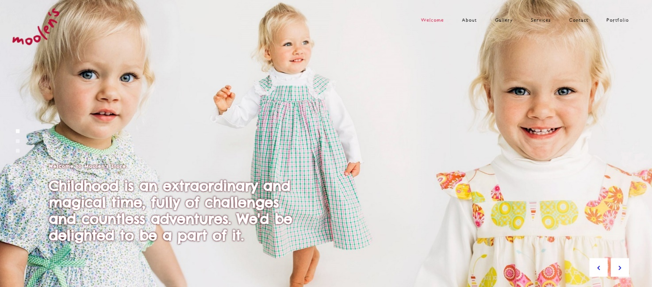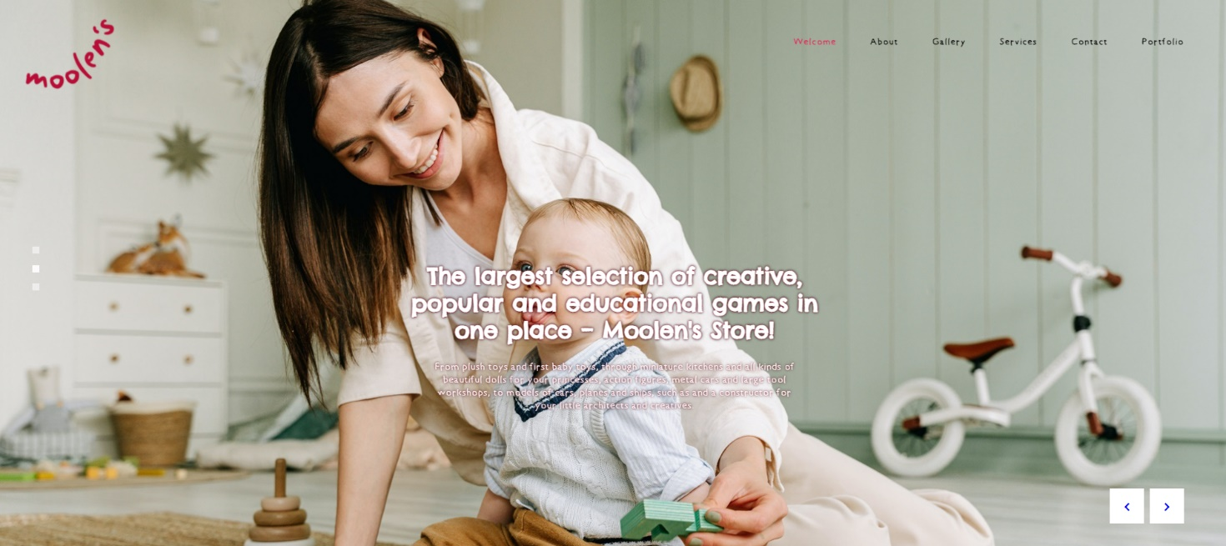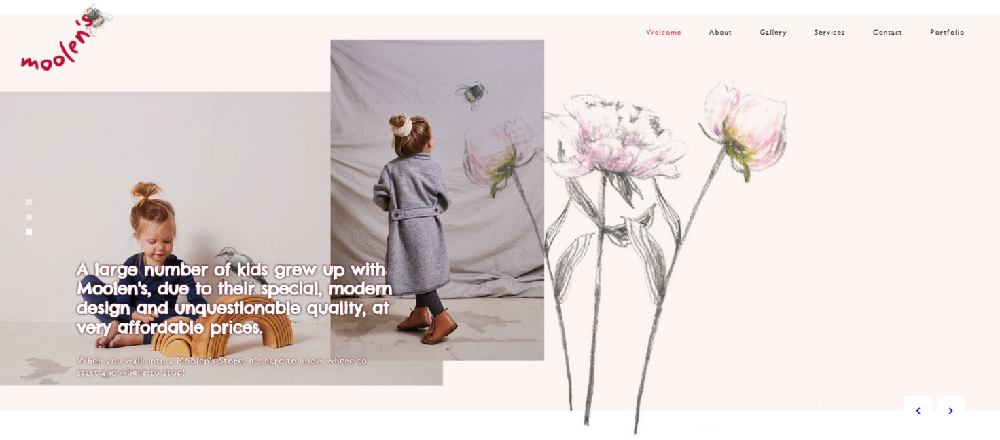

*U narenoj sekciji svakom elementu sa pozadinskom slikom dodeljena je jednostacna animacija napisana u jQuery-ju.*

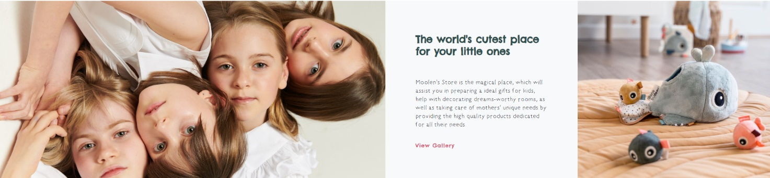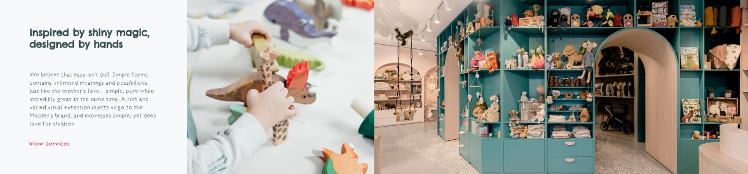

*Klikom na taster „Our Story“ prikazuje se modal u kojem se nalaze informacije o samom brendu Moolen’s. Otvoren modal moguće je zatvoriti klikom na ikonicu* ✕ *u gornjem desnom uglu.*

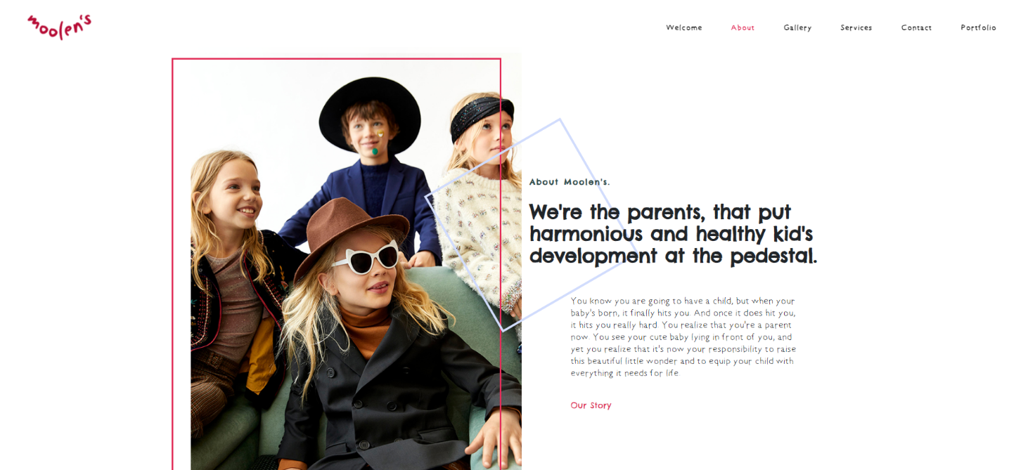

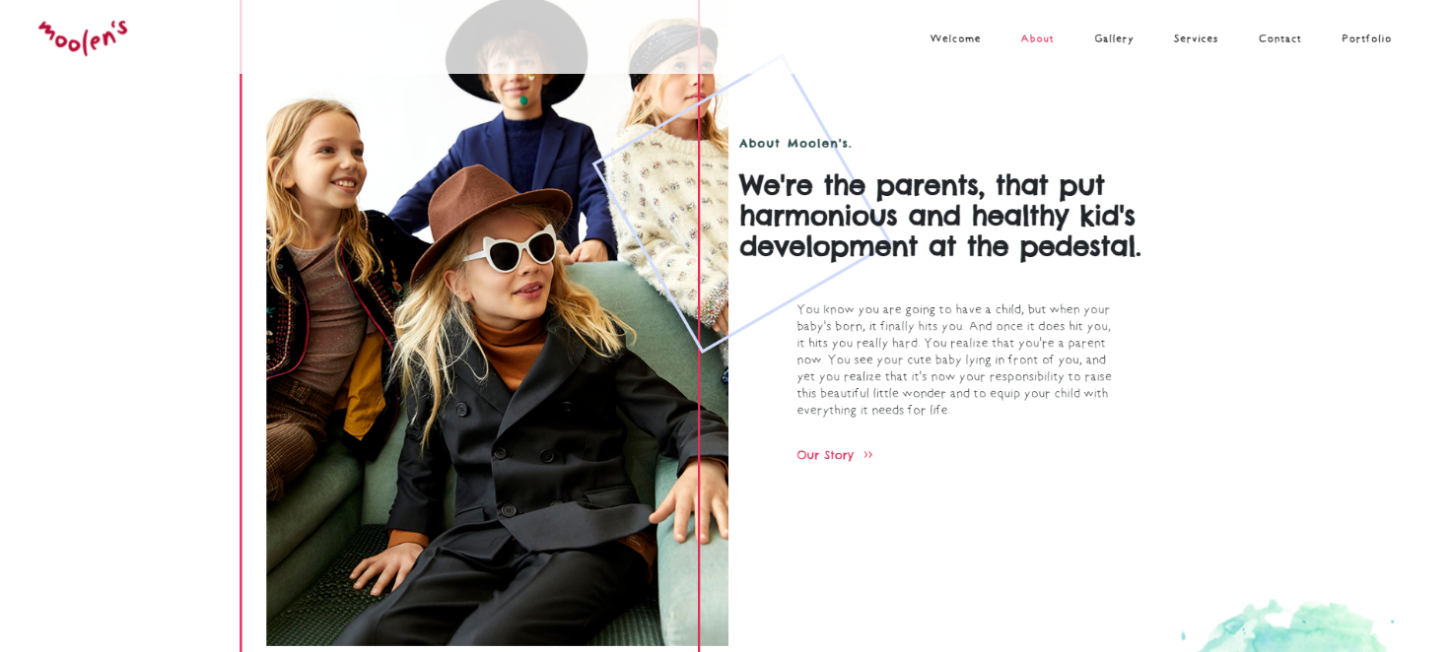

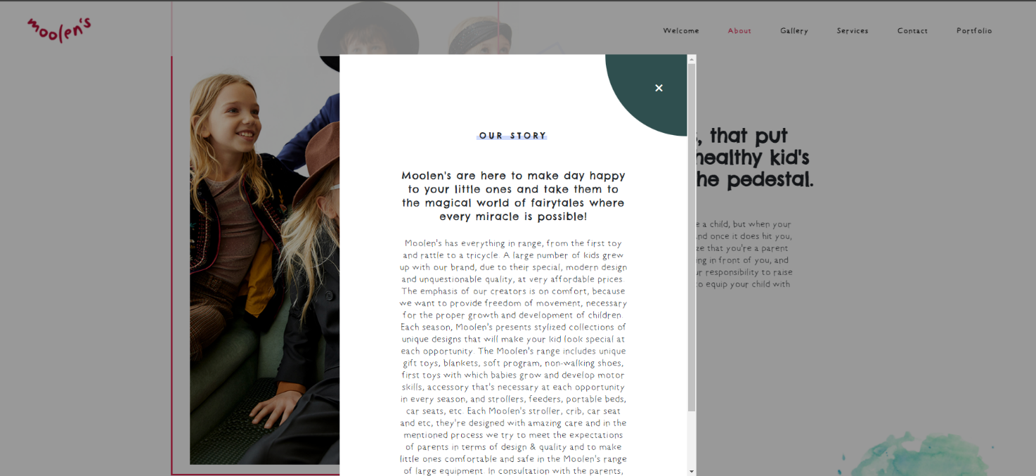

*Dinamički kreirana galerija slika u kojoj je po default-u proširen prvi element i prikazan njegov sadržaj, dok su ostali elementi skupljeni. Svakom elementu je dodeljena mogućnost promene prelaksom kursora miša preko samog elementa, kada on postaje aktivni (prošireni) element. Onog trenutka kada kursor miša izađe iz okvira sekcije „Galley“, sekcija se vraća u svoj podrazumevani izgled (prvi element proširen, dok su ostali skupljeni). Funkcionalnost je prilagođena za dve prelomne tačke: (min-width: 900px) i (max-width: 899px).*

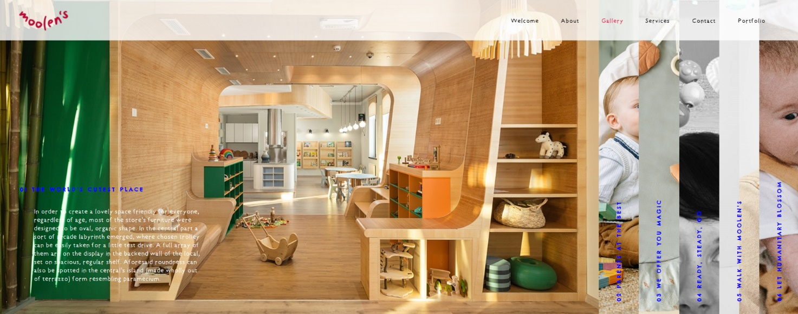

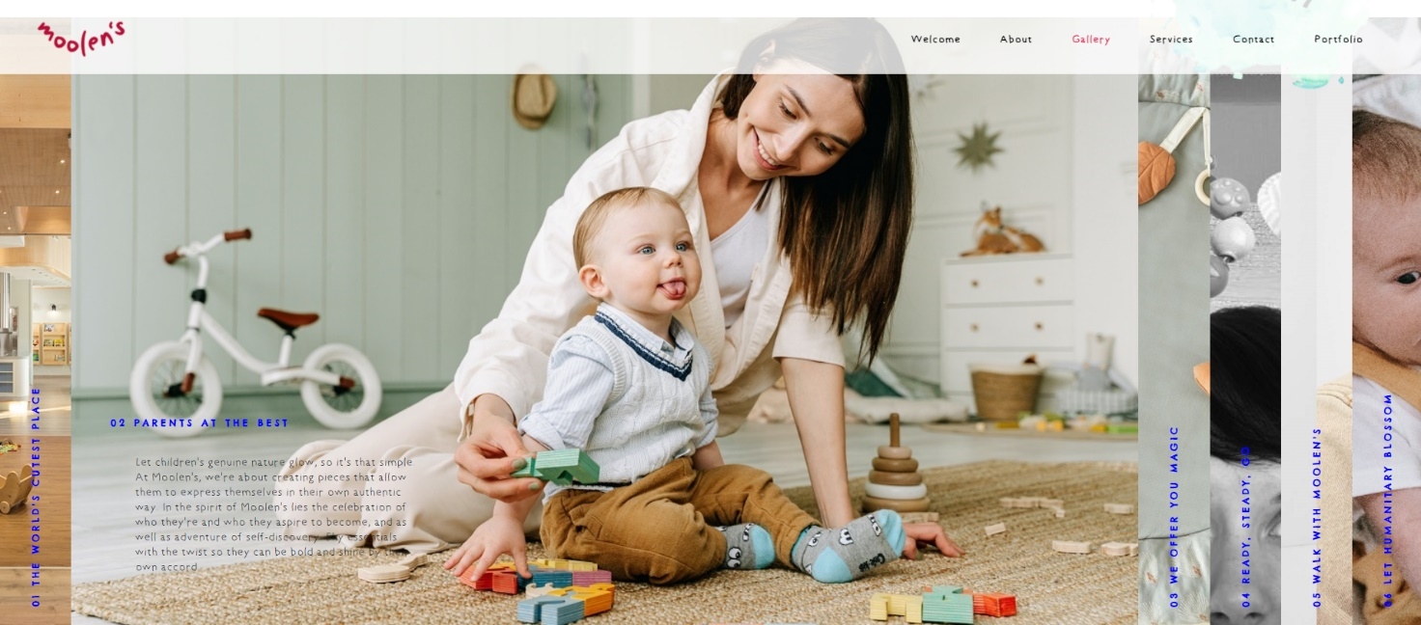

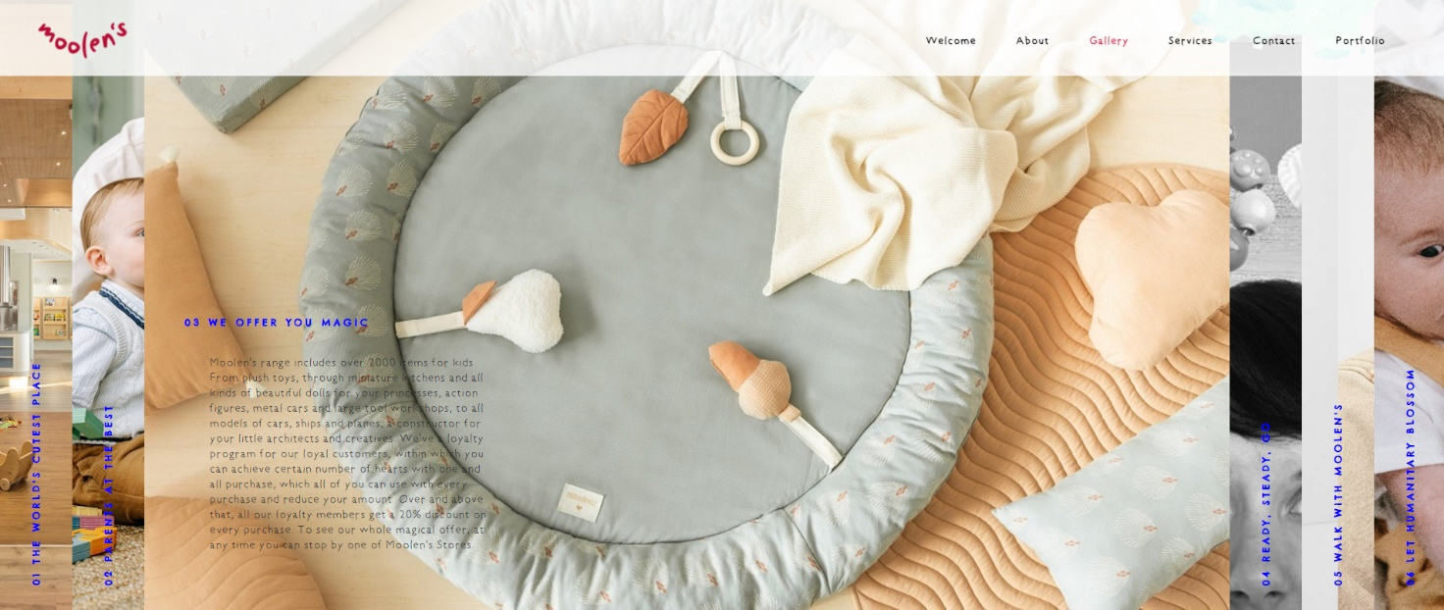

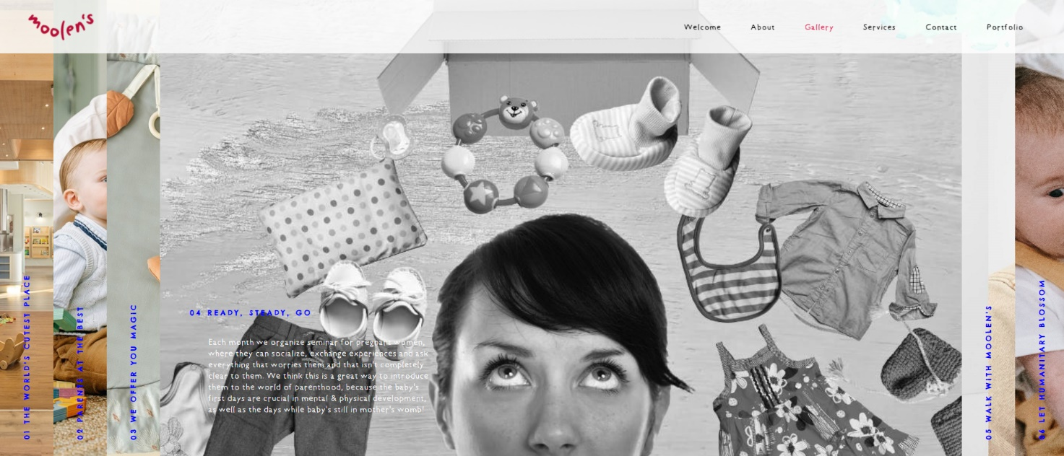

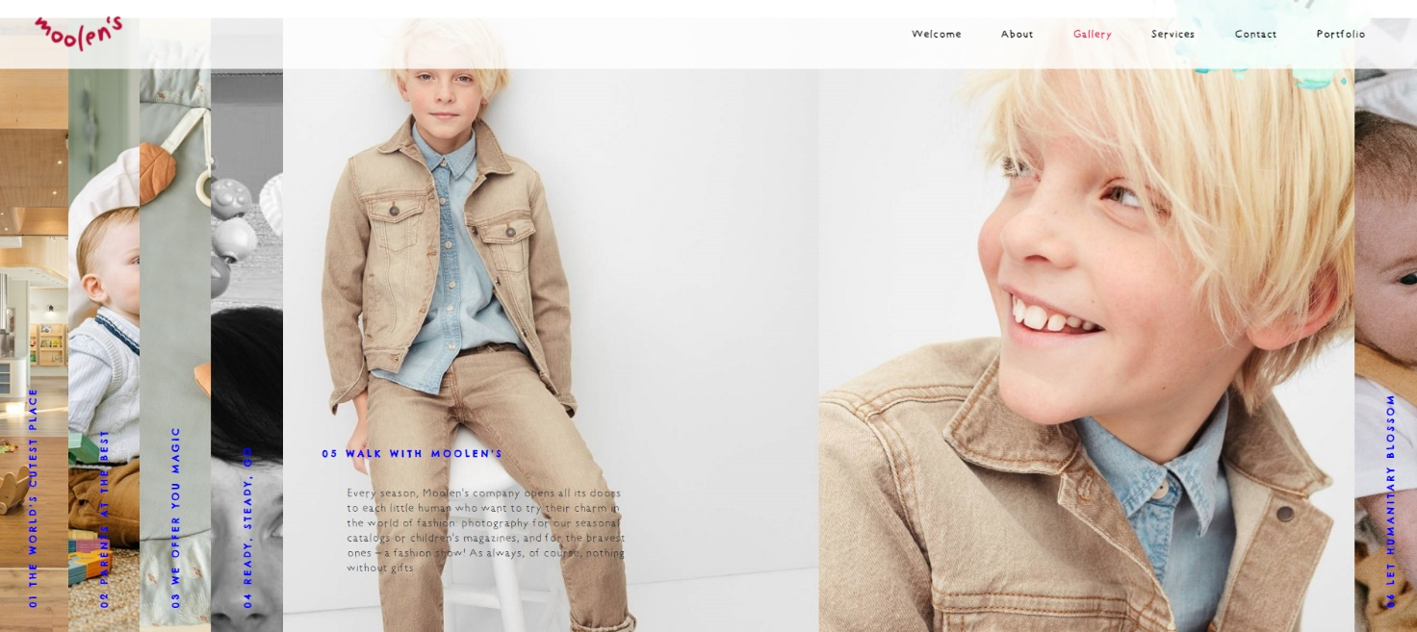

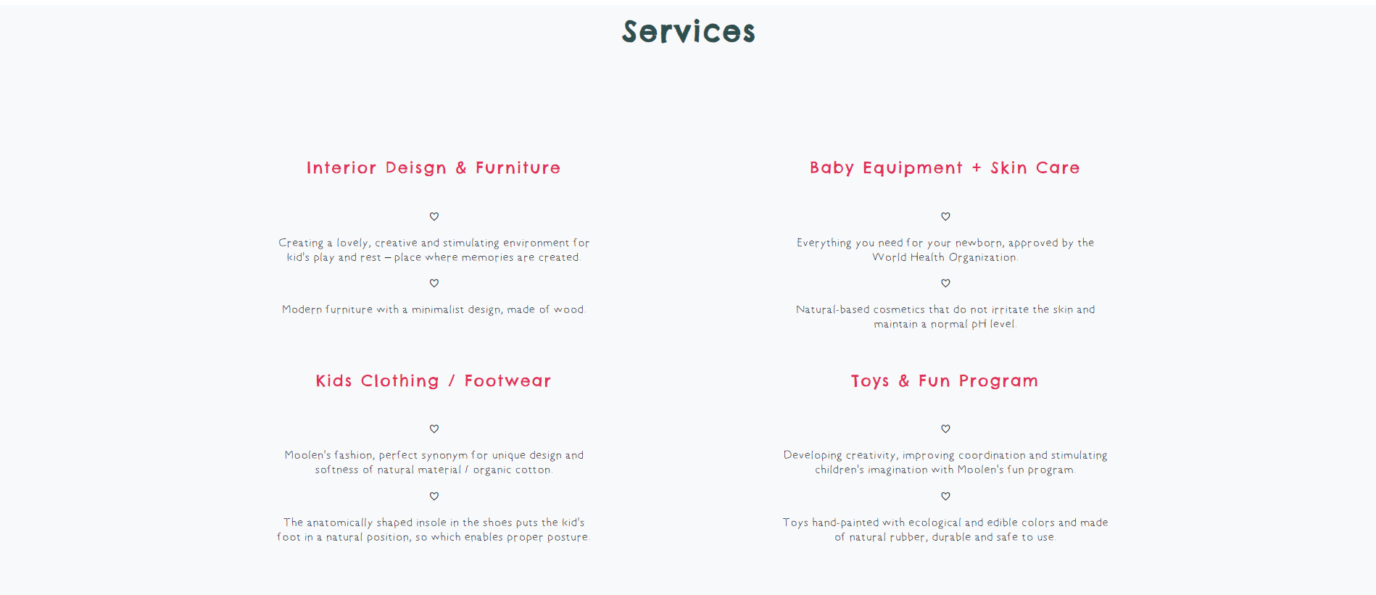

*Dinamički ispisana sekcija sa automatskim brojačima. U okviru svakog brojača, elementu koji u svom value atributu čuva informaciju o broju koji treba da se ispiše, dodeljena je animacija automatskog inkrementiranja za određenu vrednost. Onog trenutka kada korisnik dođe do tačke gde je sekcija u vidnom polju, sve animacije se aktiviraju i izvršavaju istovremeno.*

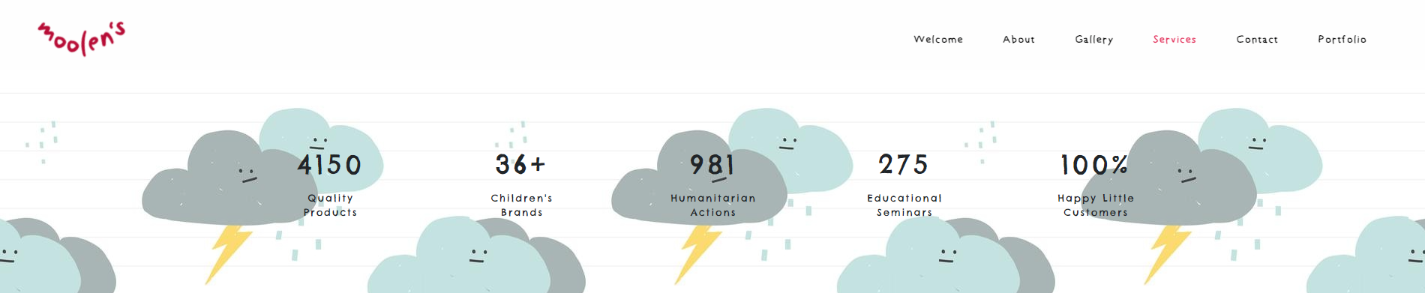

*Dinamički kreirana kontakt forma koja sadrži sledeće elemente: polje za ime i prezime, polje za e-mail adresu, drop down listu, polje za datum, polje za vreme, polje za unos poruke i dugme za submit-ovanje. Obazezna su sledeća polja: polje za ime i prezime, polje za e-mail adresu i polje za unos poruke.*

*Ukoliko korisnik želi da zakaže posetu nekoj od preporučenih prodavnica ili pak zakaže razgovor može iz opcione drop down liste izabrati najbliži objekat, nakon čega se otvara mogućnost izbora datuma. Kada korisnik izabere datum, otvara se mogućnost biranja termina. Jednom kada korisnik izabere neku stavku iz drop down liste, sva polja se smatraju obaveznim, u suprotnom obavezna su samo gore napomenuta polja.*

*Nakon promene stanja polja, korisniku se ispisuje poruka da li je uneti sadržaj ispravno formatiran ili ne. Za ime i prezime, kao i za e-mail adresu format se proverava na osnovu regularnog izraza, dok se za poruku smatra da je polje ispravno popunjeno ukoliko je unet bar jedan karakter. Polja za datum i vreme validiraju se u zavisnosti od radnih dana i ranih sati objekata.*

*Ukoliko je korisnik popunio bar polje za datum, a potom promeni izbor opcije iz padajuće liste, tada se izabrane vrednosti u poljima za datum i vreme poništavaju i polje za vreme opet postaje nedostupno za unos dok korisnik ne izabere datum. Ukoliko korisnik pak izabere nultu opciju tj. podrazumevani tekst oba polja postaju nedostupna za unos.*

*Ukoliko korisnik želi da submit-uje formu koja nije ispravno popunjena, taj zahtev će se odbiti tj. ništa se neće dogoditi. Ukoliko korisnik submit-uje praznu formu, to takođe neće biti moguće, ali u ovom slučaju neće biti prikazane greške (prikazuju se samo kada se stanje nekog polja promeni, a u kontekstu punog termina tek nakon što se i polje za datum i polje za vreme popune).*

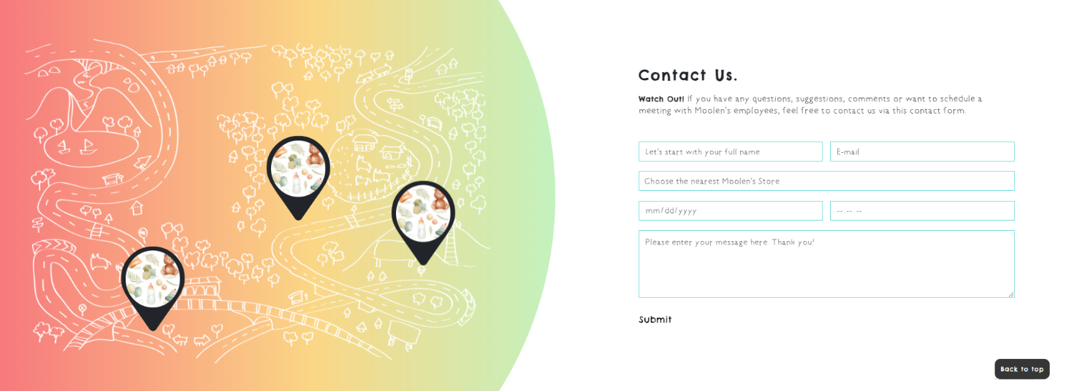

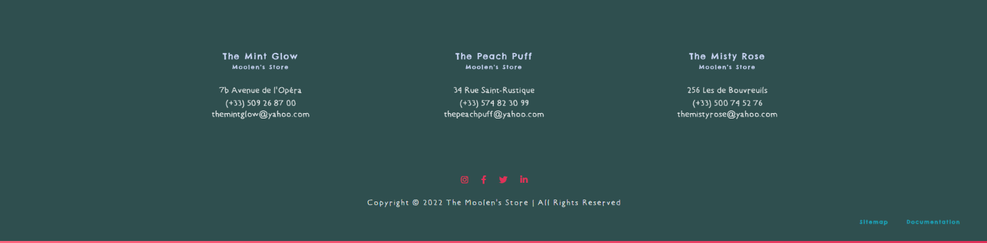

### *2.3.2* [*https://cirictamara.github.io/portfolio/*](https://cirictamara.github.io/portfolio/)

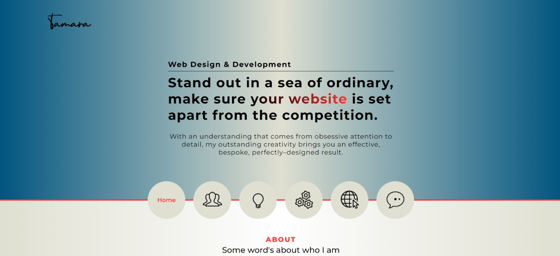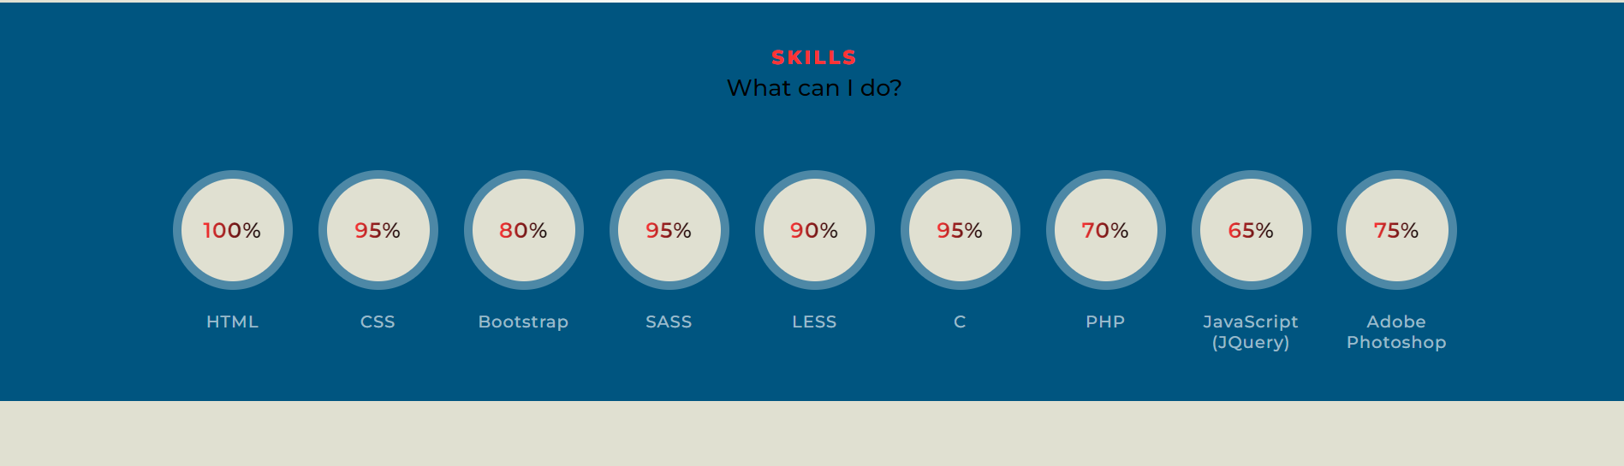

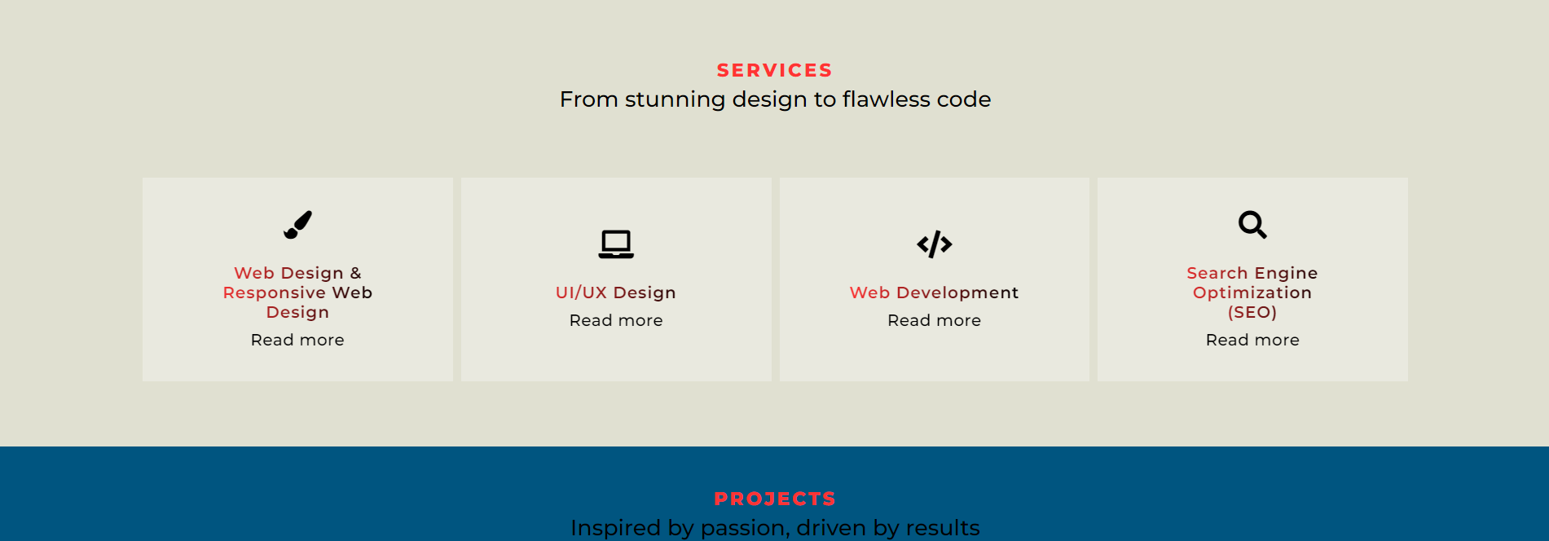

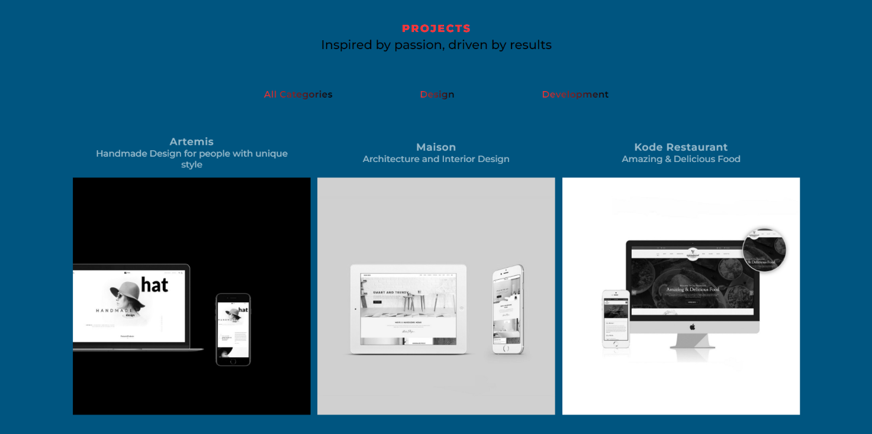

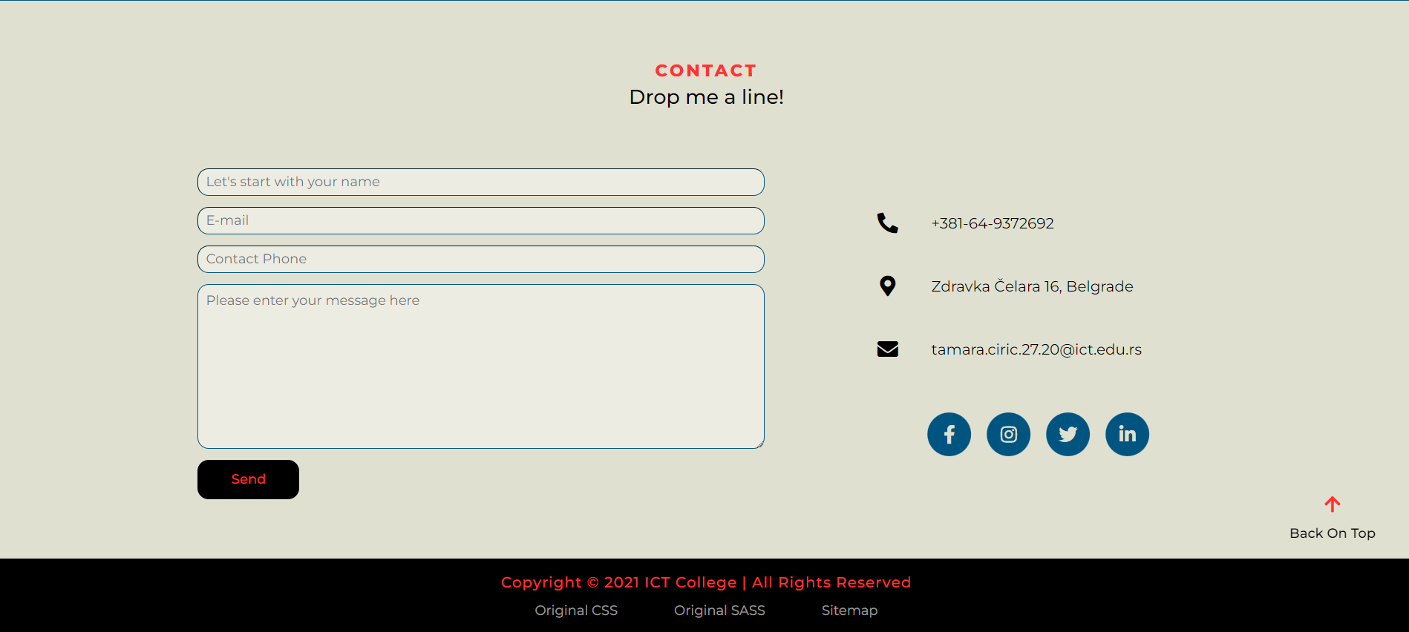

# *3. Kodovi*

## *3.1 HTML*

### *3.1.1 index.html*

<!DOCTYPE *html*>

<html *lang* = "en">

    <head>

*<!-- [meta tags] -->*

        <meta *charset* = "utf-8" />

        <meta *http-equiv* = "X-UA-Compatible" *content* = "IE = edge" />

        <meta *name* = "viewport" *content* = "width = device-width, initial-scale = 1.0" />

        <meta *name* = "description" *content* = "Childhood is an extraordinary and magical time, full of shiny challenges and countless adventures. We'd be delighted to be a part of it. Welcome to Indiana World!" />

        <meta *name* = "keywords" *content* = "Moolen's Store, baby equipment, kids clothing, toys" />

        <meta *name* = "author" *content* = "Tamara Ćirić 27/20" />

*<!-- Shortcut Icon -->*

        <link *rel* = "shortcut icon" *href* = "assets/img/favicon.ico" />

*<!-- Bootstrap CSS -->*

        <link *rel* = "stylesheet" *href* = "https://cdn.jsdelivr.net/npm/bootstrap@4.5.3/dist/css/bootstrap.min.css" *integrity* = "sha384-TX8t27EcRE3e/ihU7zmQxVncDAy5uIKz4rEkgIXeMed4M0jlfIDPvg6uqKI2xXr2" *crossorigin* = "anonymous" />

*<!-- Template CSS -->*

        <link *rel* = "stylesheet" *type* = "text/css" *href* = "assets/css/style.css" />

        <link *rel* = "stylesheet" *type* = "text/css" *href* = "assets/css/responsive.css" />

*<!-- AOS -->*

        <link *href* = "https://unpkg.com/aos@2.3.1/dist/aos.css" *rel* = "stylesheet" />

*<!-- Font Awesome -->*

        <script *src* = "https://kit.fontawesome.com/fcda4003e2.js" *crossorigin* = "anonymous"></script>

*<!-- Title -->*

        <title>Moolen's Store &verbar; The world's cutest place for your little ones</title>

    </head>

    <body>

        <div *id* = "page-loader" *class* = "w-100 vh-100 fixed-top"></div>

        <div *id* = "page-progress" *class* = "w-100 position-fixed"></div>

        <header *id* = "header" *class* = "fixed-top"></header>

        <main *class* = "container-fluid">

            <section *id* = "slider" *class* = "position-relative"></section>

            <section *id* = "zoom-effects"></section>

            <section *id* = "about" *class* = "row-12"></section>

            <section *id* = "modal-our-story" *class* = "container-fluid vh-100 d-none fixed-top"></section>

            <section *id* = "gallery" *class* = "p-0"></section>

            <section *id* = "services" *class* = "px-sm-3 px-lg-5 bg-light"></section>

            <section *id* = "number-counters" *class* = "row-12"></section>

            <section *id* = "contact" *class* = "row-12 position-relative py-5">

                <div *id* = "background" *class* = "col-12 col-xl-7 position-absolute"></div>

                <div *id* = "map" *class* = "col-12 col-sm-10 col-md-9 col-lg-8 col-xl-6 position-relative order-2 order-xl-1">

                    <div *id* = "map-markers" *class* = "w-100 h-100 position-absolute"></div>

                    <img *src* = "assets/img/map.png" *alt* = "Map drawing" />

                </div>

                <div *id* = "contact-us" *class* = "col-10 col-md-9 col-lg-8 col-xl-5 mt-4 mb-5 my-sm-5 my-xl-0 order-1 order-xl-2">

                    <div *class* = "w-100 mb-4 pb-3"></div>

                    <form *method* = "post" *action* = "" *name* = "contact-form" *id* = "contact-form"></form>

                </div>

            </section>

        </main>

        <footer *id* = "footer" *class* = "container-fluid text-center bg-darkslatergray"></footer>

*<!-- jQuery -->*

        <script *src* = "https://code.jquery.com/jquery-3.6.0.min.js" *integrity* = "sha256-/xUj+3OJU5yExlq6GSYGSHk7tPXikynS7ogEvDej/m4=" *crossorigin* = "anonymous"></script>

*<!-- jQuery Plug-in -->*

        <script *src* = "http://ajax.googleapis.com/ajax/libs/jquery/1.10.2/jquery.min.js"></script>

        <script *src* = "assets/jquery-plugin/scroll-to-top.js"></script>

*<!-- Template JavaScript -->*

        <script *type* = "text/javascript" *src* = "assets/js/main.js"></script>

*<!-- AOS -->*

        <script *src* = "https://unpkg.com/aos@2.3.1/dist/aos.js"></script>

        <script>AOS.**init**();</script>

    </body>

</html>

## *3.2 CSS*

### *3.2.1 style.css*

@import **url**("https://fonts.googleapis.com/css2?family=Chelsea+Market&display=swap");

@font-face {

    font-family: '5 Years Old Font';

    src: **url**('../font/5_Years_Old_Font.ttf');

}

:root {

    --green: **rgb**(0, 180, 0);

    --red: **rgb**(255, 0, 0);

    --grey: **rgb**(59, 59, 59);

    --pink: **rgb**(226, 47, 89);

    --rose: **rgb**(253, 201, 214);

    --light-blue: **rgb**(209, 220, 253);

    --darkslategray: darkslategray;

}

html {scroll-behavior: smooth;}

* {

    padding: 0;

    margin: 0;

    word-wrap: break-word;

    font-family: '5 Years Old Font';

    font-size: 17.5px;

    background-repeat: no-repeat;

    background-position: center;

    background-size: cover;

    letter-spacing: -0.2px;

}

*/* Tags */*

h1, h2, h3, h4, h5, a:not(.nav-link, #footer a), .arrows > span {font-family: 'Chelsea Market', cursive;}

h1, h2, h3, h4:not(#services h4), .nav-link {font-weight: 700;}

p {margin-bottom: 0 **!important**;}

a {text-decoration: none **!important**;}

ul, ol {list-style-type: none;}

img {width: 100% **!important**;}

button {

    outline: none **!important**;

    border: 0 **!important**;

    background-color: transparent **!important**;

}

*/* Bootstrap Classes */*

.container-fluid, .nav-link {padding: 0 **!important**;}

.d-none {display: none **!important**;}

.w-auto {width: fit-content **!important**;}

.cursor-pointer {cursor: pointer **!important**;}

.z-1 {z-index: 1 **!important**;}

*/* CSS Classes */*

.w-85 {width: 85%;}

.w-80 {width: 80%;}

.w-70 {width: 70%;}

.w-60 {width: 60%;}

.w-49 {width: 49%;}

.w-40 {width: 40%;}

.w-20 {width: 20%;}

*/* Text Classes */*

.font-family {font-family: "Chelsea Market", cursive;}

.text-vertical {

    writing-mode: vertical-lr;

    transform: **rotate**(180deg);

}

.fs-40 {font-size: 40px;}

.fs-35 {font-size: 35px;}

.fs-25 {font-size: 25px;}

.fs-22 {font-size: 22px;}

.fs-19 {font-size: 19px;}

.fs-16 {font-size: 16px;}

.fs-15 {font-size: 15px;}

.fs-14 {font-size: 14.5px;}

.fs-13 {font-size: 13px;}

.fs-12 {font-size: 12.5px;}

.fs-11 {font-size: 11px;}

.fs-10 {font-size: 10px;}

.ls-5 {letter-spacing: 5px;}

.ls-4 {letter-spacing: 4px;}

.ls-3 {letter-spacing: 3px;}

.ls-2 {letter-spacing: 2px;}

.ls-1 {letter-spacing: 1px;}

.ls-0 {letter-spacing: 0.5px;}

*/* Color Classes */*

.valid {color: **var**(--green);}

.invalid {color: **var**(--red);}

.bg-darkslatergray {background-color: **var**(--darkslategray);}

.darkslatergray {color: **var**(--darkslategray);}

.text-pink {color: **var**(--pink) **!important**;}

.text-light-blue {color: **var**(--light-blue);}

*/* Animations */*

@keyframes hide-1 {

    0% {transform: **scale**(0.8)}

    50% {transform: **scale**(0)}

    100% {transform: **scale**(0.8)}

}

@keyframes hide-2 {

    0% {transform: **scale**(0)}

    50% {transform: **scale**(0.8)}

    100% {transform: **scale**(0)}

}

@keyframes blur {

    from {filter: **blur**(3px)}

    to {filter: **blur**(0)}

}

@keyframes moving {

    0% { transform: **translateY**(0); }

    100% { transform: **translateY**(-10px); }

}

*/* [Page Loader] [Page Progess Bar] */*

#page-loader > div:first-of-type {animation: hide-1 2.2s ease-out infinite;}

#page-loader > div:last-of-type {animation: hide-2 1.7s ease-out infinite;}

#page-loader > div {width: 250px;}

#page-loader {background-color: **rgb**(149, 255, 255);}

#page-progress {

    height: 6px;

    bottom: 0;

    z-index: 5;

}

.progress-bar {

    width: 0%;

    background: **linear-gradient**(to right, **rgb**(255, 100, 126), **var**(--pink));

}

*/* [Header] [Footer] */*

#header {

    padding: 10px 70px 10px 30px;

    z-index: 2;

}

#logo {

    width: 160px;

    transform: **rotate**(-20deg);

    top: 35px;

}

#header, #logo {transition: 0.2s;}

#header a.active {color: **var**(--pink);}

#header a {color: **rgb**(0, 0, 0);}

#footer {padding: 100px 0 27px **!important**;}

.store > main > p {font-size: 16.5px;}

.store > main > p:last-of-type {line-height: 18px;}

#social-media > li:not(li:last-of-type) {margin-right: 25px;}

.fa-instagram:hover {

    color: transparent;

    background: **-webkit-radial-gradient**(30% 107%, circle, #fdf497 0%, #fdf497 5%, #fd5949 45%, #d6249f 60%, #285AEB 90%);

    background-clip: text;

    -webkit-background-clip: text;

}

.fa-facebook-f:hover {color: **rgb**(66, 104, 179);}

.fa-twitter:hover {color: **rgb**(29, 161, 242);}

.fa-linkedin-in:hover {color: **rgb**(134, 136, 138);}

*/* [index.html] */*

#slide-1 > .slide-content, #slide-3 > .slide-content {bottom: 15%; left: 120px;}

#slide-1 > .slide-content {width: 780px;}

#slide-2 > .slide-content {

    width: 730px;

    bottom: 25%;

}

#slide-3 > .slide-content {width: 700px}

.slide {

    animation: blur 1s ease;

    animation-fill-mode: both;

    color: **var**(--white);

    text-shadow: 0 0 3px **rgb**(200, 37, 64), 0 0 5px **rgb**(0, 0, 0);

}

#slider p.fs-16 {line-height: 20px;}

#slider p.fs-19 {line-height: 22px;}

#indicators {left: 50px;}

#indicators > li {

    width: 11px;

    height: 11px;

    transition: background-color 1s ease;

}

#indicators > li:first-of-type {background-color: **rgba**(255, 255, 255, 0.9);}

#indicators > li:not(li:first-of-type) {background-color: **rgba**(255, 255, 255, 0.5);}

#slider-controls {

    right: 70px;

    bottom: 40px;

}

#slider-controls a {

    padding: 7px 22px 10px;

    color: **rgb**(0, 0, 255);

}

#zoom-effects > * {height: 450px;}

.img-holder {transition: all 1s;}

#image-1 > .img-holder {background-image: **url**('../img/kids.jpg');}

#image-2 > .img-holder {background-image: **url**('../img/toys-1.jpg');}

#image-3 > .img-holder {background-image: **url**('../img/toys-2.jpg');}

#image-4 > .img-holder {background-image: **url**('../img/store.jpg');}

#zoom-effects > div.px-6 {padding: 30px 55px 30px 75px;}

#zoom-effects > div.px-6 > p {

    width: 95%;

    font-size: 15.5px;

    line-height: 21px;

}

.arrows > span {position: relative;}

.arrows, .arrows > span, .arrows span:after {transition: all 0.5s;}

.arrows span:after {

    content: '\276F\276F';

    position: absolute;

    opacity: 0;

    top: 1px;

    right: -20px;

    font-size: 11px;

}

.arrows:hover span {padding-right: 25px;}

.arrows:hover span:after {

    opacity: 1;

    right: 0;

}

#about, #number-counters {padding: 100px 0;}

#about > div {position: relative **!important**;}

#border-1 {

    width: 95%;

    height: 100%;

    top: 20px;

    left: -20px;

    border: 3px solid **var**(--pink);

}

#border-2 {

    width: 15vw;

    height: 15vw;

    top: 20%;

    right: -23.2%;

    border: 4px solid **var**(--light-blue);

    transform: **rotate**(-30deg);

}

#about h2 {word-spacing: 1px;}

#about > div:last-of-type {width: 600px;}

#about > div > p.fs-35 {line-height: 40px;}

#about > div > p:last-of-type {line-height: 22px;}

#about .ml-6 {

    margin-left: 75px;

    padding-right: 35px;

    letter-spacing: -0.5px;

}

#modal-our-story {

    z-index: 4;

    background-color: **rgba**(0, 0, 0, 0.4);

}

#modal-body {

    padding: 140px 90px 80px;

    width: 655px;

    height: 80vh;

    overflow-y: scroll;

}

#modal-body p:first-of-type {line-height: 25px;}

#modal-body p:last-of-type {line-height: 22px;}

#modal-body .rounded-circle {

    width: 150px;

    height: 150px;

    top: 0;

    right: 0;

    border-radius: 0 0 0 150px **!important**;

}

#close {top: 50px; right: 45px;}

#modal-body h3::after {

    content: '';

    display: block;

    height: 8px;

    position: absolute;

    bottom: 0;

    width: 130px;

    left: **calc**(50% - 68px);

    z-index: -1;

    background-color: **var**(--light-blue);

}

#gallery header {

    width: 17%;

    padding: 100px 0;

    top: -20%;

    right: 50px;

    transform: **rotate**(10deg);

    background-image: **url**('../img/brush-stroke.png');

}

#gallery h2 {margin-left: 5px;}

#gallery article.w-5 {width: 5%;}

.image {height: 85vh;}

#gallery-item-1 {background-image: **url**('../img/interior-design.jpg');}

#gallery-item-2 {background-image: **url**('../img/mom-with-baby.jpg');}

#gallery-item-3 {background-image: **url**('../img/equipment.jpg');}

#gallery-item-4 {background-image: **url**('../img/seminar.jpg');}

#gallery-item-5 {background-image: **url**('../img/editorial.jpg');}

#gallery-item-6 {background-image: **url**('../img/baby.jpg');}

#gallery article h4 {color: **rgb**(0, 0, 255);}

#gallery-item-1 > p, #gallery-item-4 > p {color: **var**(--white);}

#gallery p {

    width: 450px;

    padding-left: 33px;

    line-height: 20px;

}

#gallery-item-1 p {padding-right: 10px;}

#gallery-item-2 p, #gallery-item-5 p {padding-right: 35px;}

#gallery-item-3 p {padding-right: 40px;}

#gallery-item-4 p {padding-right: 15px;}

#gallery-item-6 p {padding-right: 25px;}

#services {padding: 80px 0 70px;}

#services > main {margin-top: 140px;}

.service > h4 {line-height: 30px;}

.service > ul > li {

    font-size: 16.5px;

    line-height: 20px;

}

.service > ul > li::before {

    display: block;

    content: '\2661';

    margin-bottom: 15px;

    font-size: 20px;

}

#number-counters {background: **url**('../img/background.jpg') repeat;}

.number-counter {width: 140px;}

.number-counter:not(#number-counter-5) {margin-right: 6vw;}

.number-counter > .number::after {display: inline-block;}

#number-counter-2 > .number::after {content: '\002B';}

#number-counter-5 > .number::after {content: '\0025';}

#background {

    height: 100%;

    clip-path: **circle**(70.0% at 30% 50%);

    background: #b4fad0 **linear-gradient**(to right, #f7797d, #fbd786, #b4fad0);

}

#map {padding-right: 110px;}

.fa-map-marker {font-size: 150px;}

#map-marker-1 {left: 18%; bottom: 10%;}

#map-marker-2 {left: 45%; top: 30%;}

#map-marker-3 {

    right: 20%;

    top: 45%;

    animation: moving 0.8s infinite alternate;

}

#map-markers span {

    width: 86%;

    height: 67%;

    left: 7%;

    top: 5%;

    background-size: 110% 105%;

    background-image: **url**('../img/icons.jpg');

}

#contact-us {

    padding-left: 6%;

    margin-left: 2%;

}

#contact-us > div > p {

    font-size: 16.5px;

    line-height: 21px;

}

input, textarea, select {

    width: 100% **!important**;

    background-color: **rgba**(255, 255, 255, 0.8) **!important**;

    border: 1px solid **rgb**(105, 219, 219) **!important**;

}

input, textarea {padding: 8px 10px;}

select {padding: 4px 8px;}

input, select {height: 35px;}

textarea {height: 120px;}

::placeholder, #full-name:focus, #e-mail:focus, textarea:focus, select {

    letter-spacing: -0.5px;

    color: **var**(--grey);

}

::placeholder, select, :focus:not(#submit:focus) {font-size: 16px;}

:focus, select {outline: none **!important**;}

#submit:focus {letter-spacing: 2px;}

select {appearance: none;}

form .order-4, form .order-5 {margin-bottom: 0 **!important**;}

form .order-8 {margin-bottom: 1rem **!important**;}

form p.mt-1 {margin-top: 2px **!important**;}

form p.position-relative {top: -4px **!important**;}

*/* [jQuery Plugin] */*

.scrollToTop {

    width: 50px;

    height: 50px;

    position: fixed;

    right: 47px;

    bottom: -100px;

    overflow: hidden;

    outline: none;

    opacity: 0;

    font-family: "Chelsea Market", cursive;

    font-size: 11px;

    color: **var**(--white);

    letter-spacing: 1px;

    text-indent: 100%;

    white-space: nowrap;

    background-color: **rgb**(54, 54, 54);

}

.scrollToTop_show {

    bottom: 60px;

    opacity: 1;

    z-index: 5;

}

.scrollToTop_show:focus {font-size: 12px **!important**;}

.scrollToTop_default {

    display: block;

    width: auto;

    height: auto;

    padding: 10px;

    text-indent: 0;

    border-radius: 10px;

}

### *3.2.2 responsive.css*

@media screen and (max-width: 1650px) {

    #zoom-effects .w-50 {width: 100% **!important**;}

    #zoom-effects .w-25 {width: 50% **!important**;}

    #zoom-effects .order-4 {order: 5 **!important**;}

    #zoom-effects .order-5 {order: 4 **!important**;}

    #zoom-effects > div.px-6 {padding: 30px 70px **!important**;}

    #zoom-effects > div.px-6 > p {

        width: 100%;

        font-size: 16.5px;

    }

}

@media screen and (max-width: 1630px) {

    #about > div.col-4 {margin-left: 10%;}

}

@media screen and (max-width: 1550px) {

    .service > ul {width: 80% **!important**;}

    #map {padding-right: 80px;}

}

@media screen and (max-width: 1480px) {

    .service > ul {width: 90% **!important**;}

    .fa-map-marker {font-size: 130px;}

    #map {padding-right: 50px;}

    #contact-us > div > p {

        font-size: 15px;

        line-height: 18px;

    }

    #contact-us > div > p > span {font-size: 11px;}

    ::placeholder, select, option, :focus:not(#submit:focus) {font-size: 15px **!important**;}

}

@media screen and (max-width: 1400px) {

    #slide-1 > .slide-content, #slide-3 > .slide-content {bottom: 13%;}

    #slide-2 > .slide-content {bottom: 20%;}

    .store:nth-of-type(2) {margin: 0 50px;}

}

@media screen and (max-width: 1370px) {

    #gallery header {width: 23%;}

    #service-1 > h4, #service-2 > h4 {width: 70% **!important**;}

    .service > ul {width: 100% **!important**;}

}

@media screen and (max-width: 1350px) {

    #map {padding-left: 0 **!important**;}

}

@media screen and (max-width: 1320px) {

    .service {padding: 0 35px **!important**;}

    #service-1, #service-3 {margin-right: 40px **!important**;}

    .number-counter {width: 120px;}

    .number {font-size: 30px;}

    .text {font-size: 12px;}

}

@media screen and (max-width: 1199px) {

    .img-1 {display: none;}

    .img-2 {display: block **!important**;}

    #about > div {left: 3%;}

    #about > div > p.fs-35 {

        font-size: 32px;

        line-height: 37px;

    }

    #gallery header {top: -15%;}

    #service-1, #service-3 {margin-right: 0 **!important**;}

    .service > h4 {font-size: 20px;}

    #service-1 > h4, #service-2 > h4 {width: 60% **!important**;}

    .service > ul > li {font-size: 16px;}

    #map {

        padding-right: 60px;

        margin-left: 90px **!important**;

    }

    #contact-us > div > p {

        font-size: 16px;

        line-height: 19px;

    }

    #contact-us > div > * {color: **rgb**(31, 27, 27);}

    #contact-us > div > p > span {font-size: 11.5px;}

    #submit {font-size: 15px;}

    .store:nth-of-type(2) {margin: 0;}

}

@media screen and (max-width: 1100px) {

    #service-1 > h4, #service-2 > h4 {width: 70% **!important**;}

}

@media screen and (max-width: 1070px) {

    .slide-content {

        width: 80% **!important**;

        left: unset **!important**;

        bottom: 150px **!important**;

        text-align: center **!important**;

    }

}

@media screen and (max-width: 1020px) {

    #gallery header {width: 27%;}

}

@media screen and (max-width: 1000px) {

    #zoom-effects .order-2, #zoom-effects .order-4 {text-align: center;}

    #zoom-effects a {margin: 0 auto **!important**;}

    #about > div > p.fs-35 {

        font-size: 32px;

        line-height: 37px;

    }

    #about > div > p.fs-35, #about h2 {margin-left: 30px;}

    #services {padding: 70px 0 40px;}

    .service {padding: 0 30px **!important**;}

    #service-1 > h4, #service-2 > h4 {width: 100% **!important**;}

    .service > ul > li {font-size: 16.5px;}

    .number-counter {width: 100px;}

    .number {font-size: 25px;}

    #map {margin-left: 60px **!important**;}

}

@media screen and (max-width: 992px) {

    .store > * {width: auto **!important**;}

    #footer {padding: 60px 0 25px **!important**;}

}

@media screen and (max-width: 991px) {

    #header {padding: 0 0 20px **!important**;}

    #logo {

        width: 120px;

        top: 30px;

    }

    .navbar-toggler, #logo {z-index: 4 **!important**;}

    .navbar-toggler {top: 50px; right: 30px;}

    .navbar-nav {

        width: 100%**!important**;

        height: 100vh **!important**;

        position: absolute **!important**;

        z-index: 3;

        display: none **!important**;

        top: 0 **!important**;

        display: flex;

        justify-content: center;

        align-items: center;

        flex-direction: column;

        text-align: center;

        background-color: **rgba**(255, 255, 255, 0.8);

    }

    #header li:not(li:last-of-type) {margin-bottom: 30px **!important**;}

    #header a {

        font-family: "Chelsea Market", cursive;

        letter-spacing: 3px **!important**;

    }

    .show {display: flex **!important**;}

    #services > main {margin-top: 80px;}

}

@media screen and (max-width: 980px) {

    #about > div:last-of-type {left: 1%;}

}

@media screen and (max-width: 950px) {

    #about > div:first-of-type {left: 4%;}}

@media screen and (max-width: 925px) {

    #about > div:first-of-type {left: 6%; top: 20px;}

    #about > div:last-of-type {left: 0;}

    #about > div > p.fs-35, #about h2 {margin-left: 50px;}

}

@media screen and (max-width: 920px) {

    .text {font-size: 11px;}

}

@media screen and (max-width: 899px) {

    #zoom-effects .order-2, #zoom-effects .order-4 {width: 100% **!important**;}

    #zoom-effects .order-3, #zoom-effects .order-5 {

        width: 50vw **!important**;

        height: 50vw;

    }

    #zoom-effects > div.px-6  {

        height: auto;

        padding: 60px **!important**;

    }

    #zoom-effects > div.px-6 > p {

        font-size: 16px;

        line-height: 20px;

    }

    #about > div:first-of-type {left: 8%; top: 0;}

    #border-2 {

        top: 80% **!important**;

        right: 90.5%;

    }

    #about > div:last-of-type {top: -15px; left: 6%;}

    #about > div > p.fs-35, #about h2 {margin-left: 0;}

    #about button {margin-bottom: 70px **!important**;}

    #gallery header {

        width: 100%;

        padding: 80px 0;

        top: -180px ;

        right: 0;

        transform: **rotate**(0deg) **!important**;

        background-size: auto 105% **!important**;

    }

    #gallery h2 {

        width: fit-content **!important**;

        transform: **rotate**(7deg);

    }

    #gallery h2, #gallery article:not(article.active) h4 {margin: 0 auto **!important**; }

    .image {width: 100% **!important**;}

    .text-vertical {

        writing-mode:initial **!important**;

        transform: **rotate**(0deg);

    }

    #gallery article.active {height: 85vh **!important**;}

    #gallery article.active .align-self-center {

        align-self: start **!important**;

        margin-left: 53px **!important**;

        writing-mode: horizontal-tb **!important**;

        text-align: left;

    }

    #gallery article:not(article.active), .h-7 {height: 70px **!important**;}

    #gallery article:not(article.active) {

        padding: 0 **!important**;

        justify-content: center **!important**;

    }

    #gallery article:not(article.active) h4 {

        align-self: center **!important**;

        text-align: center;

    }

    #map-marker-2 {top: 25%;}

}

@media screen and (max-width: 850px) {

    .slide-content {

        width: 90% **!important**;

        padding: 0;

        bottom: 100px  **!important**;

    }

    h1, #slider h3 {font-size: 30px **!important**;}

    #slider p.fs-19 {

        font-size: 16px **!important**;

        line-height: 18px **!important**;

    }

    #slider p.pr-5 {padding-right: 0 **!important**;}

    #indicators {left: 30px;}

    #indicators > li {

        width: 9px;

        height: 9px;

    }

    #slider-controls {right: 50px; bottom: 30px;}

    #slider-controls a {padding: 0 15px 3px;}

}

@media screen and (max-width: 835px) {

    .scrollToTop_show {bottom: 115px;}

}

@media screen and (max-width: 800px) {

    .fa-map-marker {font-size: 110px **!important**;}

}

@media screen and (max-width: 767px) {

    #about {padding-bottom: 10px **!important**;}

    #about h2 {

        writing-mode: vertical-lr;

        transform: **rotate**(180deg);

    }

    #about > div:first-of-type {left: -10px;}

    #border-2 {

        width: 30vw;

        height: 30vw;

        top: 80% **!important**;

        right: -2% **!important**;

    }

    #about > div:last-of-type {

        top: -135px **!important**;

        left: 20px;

    }

    #map {padding-right: 50px;}

    #map-marker-2 {top: 30%;}

    #contact-us {

        padding-left: 6%;

        margin-left: 30px;

        padding-right: 5%;

    }

}

@media screen and (max-width: 740px) {

    .number-counter:not(#number-counter-5) {margin-right: 4vw;}

}

@media screen and (max-width: 700px) {

    .img-2 {display: none **!important**;}

    .img-3 {display: block **!important**;}

    .slide-content {

        width: 85% **!important**;

        bottom: unset **!important**;

    }

    #modal-body {

        width: 80%;

        padding: 100px 50px 60px;

    }

    #map-marker-2 {top: 27%;}

    #footer > div > p {

        font-size: 15px;

        line-height: 21px;

    }

}

@media screen and (max-width: 680px) {

    #about > div:first-of-type {left: 10px;}

    #about > div:last-of-type {

        width: 85% **!important**;

        left: 7% **!important**;

    }

    #about > div > p:last-of-type {

        font-size: 16px;

        line-height: 20px;

    }

    #about > div > p.fs-35 {

        font-size: 30px;

        line-height: 35px;

    }

    #about p.ml-6 {

        width: 86% **!important**;

        padding-right: 0 **!important**;

    }

    #about p.ml-6, #about button {margin-left: 0 **!important**;}

    .service {padding: 0 **!important**;}

    #map-marker-2 {top: 24%;}

}

@media screen and (max-width: 670px) {

    #number-counters {padding: 70px 0;}

    .number-counter {width: 40%;}

    .number-counter:not(#number-counter-5) {

        margin-right: 0;

        margin-bottom: 30px;

    }

    #number-counter-5 {margin-right: 40%;}

    .number {font-size: 30px;}

    .text {

        width: 70%;

        font-size: 12px;

    }

}

@media screen and (max-width: 630px) {

    .fa-map-marker {font-size: 100px **!important**;}

    #map-marker-2 {top: 20%;}

}

@media screen and (max-width: 625px) {

    .store > main {margin-left: 0 **!important**;}

}

@media screen and (max-width: 615px) {

    #contact-us {

        padding-left: 6%;

        margin-left: 30px;

        padding-right: 0;

    }

}

@media screen and (max-width: 580px) {

    h1, #slider h3 {font-size: 25px **!important**;}

    #slider p.fs-16,  #slider p.fs-19 {

        font-size: 15px **!important**;

        line-height: 16px **!important**;

    }

    #modal-body {

        padding: 100px 60px 60px;

        width: 80%;

    }

    #modal-body .rounded-circle {

        width: 120px;

        height: 120px;

    }

    #close {

        top: 40px;

        right: 40px;

        font-size: 15px;

    }

    #modal-body p {

        padding-left: 0 **!important**;

        padding-right: 0 **!important**;

    }

    #modal-body p:first-of-type {

        font-size: 17px;

        line-height: 22px;

    }

    #modal-body p:last-of-type {

        font-size: 16px;

        line-height: 20px;

    }

}

@media screen and (max-width: 576px) {

    .store {margin-bottom: 40px **!important**;}

    .store > * {width: 100% **!important**;}

}

@media screen and (max-width: 575px) {

    #about > div:last-of-type {

        left: 4% **!important**;

        width: 90% **!important**;

    }

    #about > div > p.fs-35 {

        font-size: 26px;

        line-height: 30px;

    }

    #about > div > p:last-of-type {width: 87% **!important**;}

    #background {

        height: 100%;

        clip-path: unset;

    }

    #map, #contact-us {

        padding-left: 0 **!important**;

        margin-left: 0 **!important**;

        padding-right: 0 **!important**;

    }

    #map-marker-2 {top: 30%; left: 50%;}

    form > .w-49:first-of-type, form > .w-49:nth-of-type(2) {width: 100%;}

    form p {line-height: 18px;}

}

@media screen and (max-width: 570px) {

    #services h2 {font-size: 35px;}

    .service > h4 {font-size: 16px;}

}

@media screen and (max-width: 550px) {

    .image {padding: 0 30px 0 30px **!important**;}

   .image > h4, #gallery p, #gallery article.active .align-self-center {

        width: 100% **!important**;

        text-align: center **!important**;

        margin-left: unset **!important**;

        padding: 0 **!important**;

    }

    #gallery p {

        font-size: 15px;

        line-height: 17.5px;

    }

}

@media screen and (max-width: 540px) {

    .scrollToTop_show {bottom: 125px; right: 30px;}

}

@media screen and (max-width: 530px) {

    #contact-us > div > p {font-size: 15.5px;}

    .fa-map-marker {font-size: 90px **!important**;}

    #map-marker-1 {bottom: 12%;}

    #map-marker-3 {top: 50%;}

}

@media screen and (max-width: 520px) {

    #about h2 {

        writing-mode:horizontal-tb;

        transform: **rotate**(0deg);

    }

    #about > div:last-of-type {

        width: 100% **!important**;

        padding: 0  **!important**;

        left: 0  **!important**;

        top: 50px **!important**;

        text-align: center **!important**;

    }

    #about > div > p.fs-35 {

        font-size: 18px;

        letter-spacing: 0.5px;

        line-height: 25px;

        padding: 0 30px **!important**;

        width: 100% **!important**;

    }

    #about > div > p.ml-6 {width: 100%;}

    #about > div > p:last-of-type {margin: 0 auto 30px **!important**;}

    #about button {margin: 0 0 250px 35px **!important**;}

}

@media screen and (max-width: 500px) {

    #page-progress {display: none;}

    .navbar-toggler {

        top: 20px **!important**;

        right: 20px **!important**;

    }

    #modal-body {

        width: 80%;

        padding: 100px 20px 60px;

    }

}

@media screen and (max-width: 480px) {

    h1, #slider h3 {font-size: 20px **!important**;}

    #slider h2 {

        font-size: 11px;

        letter-spacing: 1px;

    }

}

@media screen and (max-width: 470px) {

    .image > h4 {

       line-height: 20px;

       font-size: 11.5px;

       letter-spacing: 2.5px;

    }

}

@media screen and (max-width: 450px) {

    .fa-map-marker {font-size: 85px **!important**;}

    #map-marker-2 {top: 27%;}

    #map-marker-3 {top: 47%;}

}

@media screen and (max-width: 440px) {

    #zoom-effects > * {width: 100%;}

    #zoom-effects .order-1, #zoom-effects .order-6 {height: 100vw;}

    #zoom-effects > div.px-6  {

        height: auto;

        padding: 50px 40px **!important**;

    }

    #zoom-effects h4 {

        font-size: 20px;

        line-height: 25px;

        letter-spacing: 1px;

    }

    #contact-us > div {text-align: center;}

    #contact-us h2 {margin-bottom: 40px **!important**;}

    #submit {

        width: 100%;

        margin-top: 10px **!important**;

    }

    form > .w-49  {width: 100%;}

    form .order-4 {margin-bottom: 1rem **!important**;}

    option {font-size: 13px **!important**;}

}

@media screen and (max-width: 430px) {

    .service > h4 {

        font-size: 17px;

        line-height: 23px;

    }

    #service-1 > h4, #service-2 > h4 {width: 75% **!important**;}

}

@media screen and (max-width: 420px) {

    .scrollToTop_show {visibility: hidden **!important**;}

}

@media screen and (max-width: 400px) {

    .slide-content {

        width: 95% **!important**;

        bottom: 60px **!important**;

    }

    #slider-controls {display: none **!important**;}

    #indicators {

        bottom: 10px **!important**;

        left: unset **!important**;

        display: flex **!important**;

        flex-direction: row **!important**;

    }

    #indicators > li:not(li:last-of-type) {

        margin-bottom: 0 **!important**;

        margin-right: 20px;

    }

    .fa-map-marker {font-size: 75px **!important**;}

    #footer > div > p {

        font-size: 14.5px;

        letter-spacing: 0.5px;

    }

}

@media screen and (max-width: 390px) {

    .number-counter {width: 70%;}

    #number-counter-5 {margin-right: 0;}

    .text {

        width: 60%;

        font-size: 12px;

    }

}

@media screen and (max-width: 380px) {

    #services > main {

        padding-left: 40px **!important**;

        padding-right: 40px **!important**;

    }

    #service-1 > h4, #service-2 > h4, .service > h4, .service > ul > li {

        font-size: 16px;

        line-height: 19px;

    }

    #footer > div {flex-direction: column **!important**;}

    .store p {font-size: 16px **!important**;}

    #footer > div > a {

        margin-left: 0 **!important**;

        margin-right: 0 **!important**;

    }

    #footer > div > a:first-of-type {margin-bottom: 10px;}

}

@media  screen and (max-width: 370px) {

    #about > div > p.fs-35 {

        font-size: 15px;

        line-height: 22px;

        letter-spacing: 1px;

    }

    #about button {margin: 0 0 200px 35px **!important**;}

    #modal-body .rounded-circle {

        width: 100px;

        height: 100px;

    }

    #close {top: 30px; right: 30px;}

}

@media screen and (max-width: 360px) {

    #map-marker-2 {left: 48%; top: 25%;}

    #map-marker-3 {top: 45%;}

    ::placeholder, select, :focus:not(#submit:focus) {line-height: 17px;}

}

@media screen and (max-width: 350px) {

    .slide-content {width: 100% **!important**;}

    h1, #slider h3 {

        font-size: 18px **!important**;

        letter-spacing: 0.5px **!important**;

    }

    #slider h2 {

        font-size: 10px;

        letter-spacing: 0.5px;

    }

    #zoom-effects h4 {

        font-size: 18px;

        letter-spacing: 0.5px;

    }

}

## *3.3 JavaScript*

### *3.3.1 main.js*

*/* Flex */*

const flexColumn = ["d-flex", "flex-column", "justify-content-center", "align-items-center"];

const flexRow = ["d-flex", "flex-row", "flex-wrap", "justify-content-center", "align-items-center"];

*// [Body]*

**addClasses**(document.**querySelectorAll**("body > *:not(#page-progress)"), flexColumn);

let sections = document.**querySelectorAll**("main > section");

for (let i = 0; i < sections.length; i++)

    sections[i].classList.**add**("w-100");

*// [Functions]*

*// Set Attributes / Add Classes / Remove Classes / Change Classes / Append Children*

function **setAttributes**(elements, attributes) {

    for (let i = 0; i < elements.length; i++)

        for (let j = 0; j < attributes.length; j += 2)

            elements[i].**setAttribute**(attributes[j], attributes[j + 1]);

}

function **addClasses**(elements, classes) {

    for (let element of elements)

        for (let i in classes)

            element.classList.**add**(classes[i]);

}

function **removeClasses**(element, classes) {

    for (let i of classes)

        element.classList.**remove**(i);

}

function **changeClasses**(element, classesRemove, classesAdd) {

**removeClasses**(element, classesRemove);

**addClasses**([element], classesAdd);

}

function **appendChildren**(element, childern) {

    for (let child of childern)

        element.**appendChild**(child);

}

*// [Page Loader]*

**$**(document).**ready**(function() {

    let loader = **$**("#page-loader");

    const loaderImages = [ {"src": "logo.png", "alt": "Moolen's Logo"},

                           {"src": "logo.png", "alt": "Moolen's Logo"} ];

    let loaderContent = "";

    for (let i = 0; i < 2; i++)

        loaderContent +=

        `<div class = "position-absolute">

             <img src = "assets/img/${loaderImages[i].src}" alt = "${loaderImages[i].alt}" />

         </div>`;

    loader.**html**(loaderContent);

    loader.**fadeOut**(2000, () => {

        loader.**addClass**("d-none");

    });

});

*// [Page Progess Bar]*

document.**getElementById**("page-progress").innerHTML = `<div class = "progress-bar h-100"></div>`;

function **progressBar**() {

    let windowScroll = document.body.scrollTop || document.documentElement.scrollTop;

    let height = document.documentElement.scrollHeight - document.documentElement.clientHeight;

    let scrolled = (windowScroll / height) * 100;

    document.**querySelector**(".progress-bar").style.width = scrolled + "%";

}

*// [On Scroll]*

*// Resizing Header / Page Progress Bar / Changing Active Link*

window.**onscroll** = function() {

**scrollFunction**();

**scrollFunction**();

};

function **scrollFunction**() {

**progressBar**();

    let x1 = window.**matchMedia**("(min-width: 992px)");

    let x2 = window.**matchMedia**("(max-width: 991px)");

    if (x1.matches) {

        if (document.body.scrollTop > 50 || document.documentElement.scrollTop > 50) {

            document.**getElementById**("logo").style.cssText = "width: 115px !important; transform: rotate(15deg); top: 0;";

            document.**getElementById**("header").style.cssText = "padding: 10px 80px 20px 50px; background-color: rgba(255, 255, 255, 0.8);";

        }

        else {

            document.**getElementById**("logo").style.cssText = "width: 160px !important; transform: rotate(-20deg); top: 35px;";

            document.**getElementById**("header").style.cssText = "padding: 10px 70px 10px 30px; background-color: none;";

        }

    }

    if (x2.matches)

        if (document.body.scrollTop > 50 || document.documentElement.scrollTop > 50) {

            document.**getElementById**("logo").style.cssText = "width: 100px !important; transform: rotate(15deg); top: 5px;";

            document.**querySelector**(".navbar-toggler").style.cssText = "top: 20px; right: 20px;";

            document.**getElementById**("header").style.cssText = "padding-bottom: 0; background-color: rgba(255, 255, 255, 0.8);";

        }

        else {

            document.**getElementById**("logo").style.cssText = "width: 120px !important; transform: rotate(-20deg); top: 30px;";

            document.**querySelector**(".navbar-toggler").style.cssText = "top: 50px; right: 30px;";

            document.**getElementById**("header").style.cssText = "padding-bottom: 20px; background-color: none;";

        }

}

**$**(document).**ready**(function () {

**$**(".nav-link").**click**(function () {

**$**(".nav-link").**removeClass**("active");

**$**(this).**addClass**("active");

    });

    let links = document.**querySelectorAll**(".nav-link:not(.nav-item:last-child > a)");

    let sections = document.**querySelectorAll**("#slider, #about, #gallery, #services, #contact");

    function **changeActiveLink**() {

        let indexSection = sections.length;

        while (--indexSection && window.scrollY + 100 < sections[indexSection].offsetTop) {}

        links.**forEach**((link) => link.classList.**remove**("active"));

        links[indexSection].classList.**add**("active");

    }

    window.**addEventListener**("scroll", **changeActiveLink**);

});

*// [jQuery Plugin] Back To Top*

**$**(document).**ready**(function($) {

**$**("body").**scrollToTop**({

        distance: 200,

        speed: 1000,

        mobile: {

            width: 768,

            distance: 100,

            speed: 1000

        },

        trigger: null,

        target: null,

        text: "Back to top",

        skin: null,

        throttle: 250,

        namespace: "scrollToTop"

    });

});

*// [Header]*

let nav = document.**createElement**("nav");

nav.classList.**add**("w-100", "navbar", "navbar-expand-lg", "navbar-light", "p-0", "d-flex", "flex-row", "justify-content-between");

**appendChildren**(nav, [**logo**(), **navigationMenuControls**(), **createNavigationMenu**()]);

document.**getElementById**("header").**appendChild**(nav);

function **createNavigationMenu**() {

    let navigationMenu = document.**createElement**("div");

    navigationMenu.classList.**add**("collapse", "navbar-collapse");

    let pages =   
 [

        {"name": "Welcome", "href": "#slider"},

        {"name": "About", "href": "#about"},

        {"name": "Gallery", "href": "#gallery-header"},

        {"name": "Services", "href": "#services"},

        {"name": "Contact", "href": "#contact"},

        {"name": "Portfolio", "href": "https://cirictamara.github.io/portfolio/"}

    ];

    let ul = document.**createElement**("ul");

    ul.classList.**add**("navbar-nav", "mt-lg-3", "ls-1");

    for (let i = 0; i < pages.length; i++) {

        let li = document.**createElement**("li");

        li.classList.**add**("nav-item");

        let a = document.**createElement**("a");

**setAttributes**([a], ["class", "nav-link fs-14 ls-0", "href", pages[i].href]);

        if (i == 0)

            a.classList.**add**("active");

        if (i != (pages.length - 1))

            li.classList.**add**("mr-lg-5");

        else

            a.**setAttribute**("target", "_blank");

        a.**appendChild**(document.**createTextNode**(pages[i].name));

        li.**appendChild**(a);

        ul.**appendChild**(li);

    }

    return ul;

}

function **logo**() {

    let a = document.**createElement**("a");

**setAttributes**([a], ["id", "logo", "class", "navbar-brand position-relative ml-3 ml-lg-0", "href", "#"]);

    a.innerHTML = `<img src = "assets/img/logo.png" alt = "Moolen's Logo" />`;

    return a;

}

function **navigationMenuControls**() {

    let button = document.**createElement**("button");

**setAttributes**([button], ["type", "button", "class", "navbar-toggler position-absolute", "data-toggle", "collapse", "data-target", "navigation-menu", "aria-controls", "navigation-menu", "aria-expanded", "false", "aria-label", "Toggle navigation"]);

    let span = document.**createElement**("span");

    span.classList.**add**("navbar-toggler-icon");

    button.**appendChild**(span);

    var clicks = 0;

    button.**addEventListener**("click", () => {

        clicks++;

        if (clicks % 2 != 0)

**changeClasses**(document.**querySelector**(".navbar-nav"), ["d-none"], ["show"]);

        else

**changeClasses**(document.**querySelector**(".navbar-nav"), ["show"], ["d-none"]);

    });

    return button;

}

*// [Section] Slider*

let slider = document.**getElementById**("slider");

**createSlideShow**();

function **createSlideShow**() {

**addClasses**([slider], flexRow);

**appendChildren**(slider, [**createSlides**(), **sliderIndicators**(), **sliderControls**()]);

}

function **createSlides**() {

    const slideImages =

    [

        {

            "img_1": {"src": "cover-1.jpg", "alt": "Girl Editorial Photos"},

            "img_2": {"src": "cover-1.gif", "alt": "Collage 1"},

            "img_3": {"src": "cover-1.jpg", "alt": "Toys on stairs"}

        },

        {

            "img_1": {"src": "cover-2.jpg", "alt": "Mom with baby"},

            "img_2": {"src": "cover-2.gif", "alt": "Collage 2"},

            "img_3": {"src": "cover-2.jpg", "alt": "Moolen's Fun Program"}

        },

        {

            "img_1": {"src": "cover-3.jpg", "alt": "Collage"},

            "img_2": {"src": "cover-3.gif", "alt": "Collage 3"},

            "img_3": {"src": "cover-3.jpg", "alt": "Interior Design"}

        }

    ];

    const slideContents =

    [

        {

            "h2": "Welcome to Moolen's Store.",

            "h1": "Childhood is an extraordinary and magical time, fully of challenges and countless adventures. We'd be delighted to be a part of it."

        },

        {

            "h3": "The largest selection of creative, popular and educational games in one place &ndash; Moolen's Store!",

            "p": "From plush toys and first baby toys, through miniature kitchens and all kinds of beautiful dolls for your princesses, action figures, metal cars and large tool workshops, to models of cars, planes and ships, such as and a constructor for your little architects and creatives."

        },

        {

            "h3": "A large number of kids grew up with Moolen's, due to their special, modern design and unquestionable quality, at very affordable prices.",

            "p": "When you walk into a Moolen's Store, it's hard to know where to start and where to stop!"

        }

    ];

    let section = document.**createElement**("section");

    section.classList.**add**("slider-inner", "w-100", "position-relative");

    for (let i = 0; i < slideContents.length; i++) {

        let article = document.**createElement**("article");

**addClasses**([article], flexColumn);

        article.**setAttribute**("id", "slide-" + (i + 1));

        article.classList.**add**("slide", "w-100", "d-none");

        let img_1 = document.**createElement**("img");

**setAttributes**([img_1], ["class", "img-1", "src", `assets/img/1/${slideImages[i].img_1.src}`, "alt", slideImages[i].img_1.alt]);

        let img_2 = document.**createElement**("img");

**setAttributes**([img_2], ["class", "img-2 d-none", "src", `assets/img/2/${slideImages[i].img_2.src}`, "alt", slideImages[i].img_2.alt]);

        let img_3 = document.**createElement**("img");

**setAttributes**([img_3], ["class", "img-3 d-none", "src", `assets/img/3/${slideImages[i].img_3.src}`, "alt", slideImages[i].img_3.alt]);

**appendChildren**(article, [img_1, img_2, img_3, **createSlideContent**(i, slideContents[i])]);

        section.**appendChild**(article);

    }

    return section;

}

function **createSlideContent**(i, content) {

    let div = document.**createElement**("div");

    div.classList.**add**("px-4", "position-absolute", "slide-content");

    switch(i) {

        case 0:

            let h2 = document.**createElement**("h2");

            h2.classList.**add**("mb-4", "position-relative", "z-1", "fs-12", "ls-2");

            h2.**appendChild**(document.**createTextNode**(content.h2));

            let h1 = document.**createElement**("h1");

            h1.classList.**add**("fs-40");

            h1.**appendChild**(document.**createTextNode**(content.h1));

**appendChildren**(div, [h2, h1]);

        break;

        case 1:

        case 2:

            let h3 = document.**createElement**("h3");

            h3.innerHTML = content.h3;

            h3.classList.**add**("pb-4", "font-family", "font-weight-bold");

            let p = document.**createElement**("p");

            p.**appendChild**(document.**createTextNode**(content.p));

            if (i == 1) {

                h3.classList.**add**("fs-35");

                p.classList.**add**("px-sm-3", "px-md-5", "fs-16");

**addClasses**([h3, p], ["m-auto", "text-center"]);

            }

            else {

                p.classList.**add**("pr-5", "fs-19");

            }

**appendChildren**(div, [h3, p]);

        break;

    }

    return div;

}

function **sliderIndicators**() {

    let ol = document.**createElement**("ol");

**setAttributes**([ol], ["id", "indicators", "class", "position-absolute"]);

    for (let i = 0; i < 3; i++) {

        let li = document.**createElement**("li");

        li.**setAttribute**("value", i);

        if (i != 2)

            li.classList.**add**("mb-3");

        ol.**appendChild**(li);

    }

    return ol;

}

function **sliderControls**() {

    let controls = document.**createElement**("div");

**setAttributes**([controls], ["id", "slider-controls", "class", "position-absolute d-flex flex-row"]);

    const buttons = [ {"id": "previous", "icon": "&lsaquo;"},

                      {"id": "next", "icon": "&rsaquo;"} ];

    for (let i = 0; i < buttons.length; i++) {

        let a = document.**createElement**("a");

**setAttributes**([a], ["id", buttons[i].id, "class", "cursor-pointer bg-white fs-25"]);

        a.innerHTML = buttons[i].icon;

        a.**addEventListener**("click", () => {

**moveSlide**(buttons[i].id);

        });

        if (i == 0)

            a.classList.**add**("mr-2");

        controls.**appendChild**(a);

    }

    return controls;

}

**$**(document).**ready**(function() {

**$**(".slide:first-of-type").**removeClass**("d-none");

    var timer;

    window.**addEventListener**("load", function() {

        timer = **setInterval**(function() {

**moveSlide**("next");

        }, 5000);

    });

**$**(".slide").**hover**(function() {

**clearInterval**(timer);

    }, function() {

        timer = **setInterval**(function() {

**moveSlide**("next");

        }, 5000);

    });

});

var slideIndex = 0;

let slides = document.**getElementsByClassName**("slide");

let indicators = document.**querySelectorAll**("#indicators > li");

function **moveSlide**(direction) {

    slides[slideIndex].classList.**add**("d-none");

    if (direction == "next") {

        slideIndex++;

        if (slideIndex == slides.length)

            slideIndex = 0;

    }

    else {

        if (slideIndex == 0)

            slideIndex = slides.length - 1;

        else slideIndex--;

    }

    slides[slideIndex].classList.**remove**("d-none");

**indicatorColorChange**(slideIndex);

}

function **indicatorColorChange**(slideIndex) {

    for (let i = 0; i < indicators.length; i++)

        if (indicators[i].**getAttribute**("value") == slideIndex)

            indicators[i].style.backgroundColor = "rgba(255, 255, 255, 0.9)";

        else

            indicators[i].style.backgroundColor = "rgba(255, 255, 255, 0.5)";

}

*// [Section] Zoom Effects*

let zoomEffectsSection = document.**getElementById**("zoom-effects");

**addClasses**([zoomEffectsSection], flexRow);

zoomEffectsSection.innerHTML = **createImageElements**() + **createTextElements**();

function **createImageElements**() {

    const attributes = [ {"id": 1, "width": "w-50", "order": "order-1"},

                         {"id": 2, "width": "w-25", "order": "order-3"},

                         {"id": 3, "width": "w-25", "order": "order-5"},

                         {"id": 4, "width": "w-50", "order": "order-6"} ];

    var content = "";

    for (let i = 0; i < attributes.length; i++)

        content +=

        `<div id = "image-${attributes[i].id}" class = "${attributes[i].width} ${attributes[i].order} overflow-hidden">

             <div class = "img-holder w-100 h-100"></div>

         </div>`;

    return content;

}

function **createTextElements**() {

    const divContent =

    [

        {

            "h4": "The world's cutest place for your little ones",

            "p": "Moolen's Store is the magical place, which will assist you in preparing a ideal gifts for kids, help with decorating dreams-worthy rooms, as well as taking care of mothers' unique needs by providing the high quality products dedicated for all their needs.",

            "a": {"name": "View Gallery", "href": "#gallery"}

        },

        {

            "h4": "Inspired by shiny magic, designed by hands",

            "p": "We believe that easy isn't dull. Simple forms contains unlimited meanings and possibilities. Just like the mother's love &ndash; simple, pure while incredibly great at the same time. A rich and varied visual extension injects virgo to the Moolen's brand, and expresses simple, yet deep love for children.",

            "a": {"name": "View Services", "href": "#services"}

        }

    ];

    var content = "";

    for (let i = 0, j = 2; i < 2; i++, j += 2)

        content +=

        `<div class = "w-25 px-6 d-flex flex-column justify-content-center order-${j} bg-light">

             <h4 class = "mb-5 fs-25 darkslatergray">${divContent[i].h4}</h4>

             <p class = "mb-4">${divContent[i].p}</p>

             <a class = "w-auto arrows" href = "${divContent[i].a.href}">

                 <span class = "position-relative fs-13 ls-1 text-pink">${divContent[i].a.name} </span>

             </a>

         </div>`;

    return content;

}

**$**(document).**ready**(function() {

**$**(".overflow-hidden").**mouseover**(function() {

**$**(this).**find**(".img-holder").**css**("transform", "scale(1.1)");

    });

**$**(".overflow-hidden").**mouseout**(function() {

**$**(this).**find**(".img-holder").**css**("transform", "scale(1)");

    });

});

*// [Section] About*

let about = document.**getElementById**("about");

**addClasses**([about], flexRow);

about.innerHTML = **createAboutSection**();

function **createAboutSection**() {

    const paragraphs =

    [

        {

            "class": "mb-5 font-family font-weight-bold fs-35",

            "text": "We're the parents, that put harmonious and healthy kid's development at the pedestal."

        },

        {

            "class": "w-75 mb-4 ml-6 pb-2",

            "text": "You know you are going to have a child, but when your baby's born, it finally hits you. And once it does hit you, it hits you really hard. You realize that you're a parent now. You see your cute baby lying in front of you, and yet you realize that it's now your responsibility to raise this beautiful little wonder and to equip your child with everything it needs for life."

        }

    ];

    var content = "";

    for (let i = 0; i < 2; i++) {

        switch(i) {

            case 0:

                content += `<div class = "col-8 col-sm-7 col-md-4">`;

                content += `<img src = "assets/img/party-look.jpg" alt = "Kids Party Look" />`

                for (let j = 0; j < 2; j++)

                    content += `<div id = "border-${j + 1}" class = "position-absolute"></div>`;

            break;

            case 1:

                content += "<div>";

                content += `<h2 class = "mb-4 fs-14 ls-2 darkslatergray">About Moolen's.</h2>`;

                for (let j = 0; j < paragraphs.length; j++)

                    content += `<p class = "${paragraphs[j].class}">${paragraphs[j].text}</p>`;

                content +=

                `<button id = "our-story" type = "button" class = "ml-6 cursore-pointer arrows">

                     <span class = "fs-14 ls-0 text-pink">Our Story </span>

                 </button>`;

            break;

        }

        content += "</div>";

    }

    return content;

}

*// [Section] Modal "Our Story"*

**addClasses**([document.**querySelector**("#modal-our-story")], flexColumn);

**$**(document).**ready**(function() {

    let paragraphs =

    [

        {

            "class": "px-3 font-family fs-19 ls-1",

            "text": "Moolen's are here to make day happy to your little ones and take them to the magical world of fairytales where every miracle is possible!"

        },

        {

            "class": "px-3 mt-4",

            "text": "Moolen's has everything in range, from the first toy and rattle to a tricycle. A large number of kids grew up with our brand, due to their special, modern design and unquestionable quality, at very affordable prices. The emphasis of our creators is on comfort, because we want to provide freedom of movement, necessary for the proper growth and development of children. Each season, Moolen's presents stylized collections of unique designs that will make your kid look special at each opportunity. The Moolen's range includes unique gift toys, blankets, soft program, non-walking shoes, first toys with which babies grow and develop motor skills, accessory that's necessary at each opportunity in every season, and strollers, feeders, portable beds, car seats, etc. Each Moolen's stroller, crib, car seat and etc, they're designed with amazing care and in the mentioned process we try to meet the expectations of parents in terms of design &amp; quality and to make little ones comfortable and safe in the Moolen's range of large equipment. In consultation with the parents, we're continuously working on brand development &amp; further bringing the brand closer to parents and kids."

        }

    ];

    let pTags = "";

    for (let i = 0; i < paragraphs.length; i++)

        pTags += `<p class = "${paragraphs[i].class}">${paragraphs[i].text}</p>`;

    let content =

    `<div id = "modal-body" class = "row-12 position-relative text-center bg-white">

         <div class = "position-absolute rounded-circle bg-darkslatergray"></div>

         <button id = "close" type = "button" class = "position-absolute cursore-pointer text-white">&#10006;</button>

         <h3 class = "mb-5 position-relative text-uppercase fs-14 ls-5 z-1">Our Story</h3>

         ${pTags}

     </div>

    `;

**$**("#modal-our-story").**html**(content);

**$**("#our-story").**click**(function() {

**$**("#modal-our-story").**removeClass**("d-none");

    });

**$**("#close").**click**(function() {

**$**("#modal-our-story").**addClass**("d-none");

    });

});

*// [Section] Gallery*

let gallery = document.**querySelector**("#gallery");

gallery.classList.**add**("container-fluid", "position-relative");

gallery.innerHTML =

`<header id = "gallery-header" class = "position-absolute z-1 text-center">

     <h2 class = "fs-35 ls-1">Gallery</h2>

 </header>`;

**createGallery**();

function **createGallery**() {

    let main = document.**createElement**("main");

    main.classList.**add**("row-12", "w-100");

**addClasses**([main], flexRow);

    const captions =

    [

        {

            "title": "The world's cutest place",

            "description": "In order to create a lovely space friendly for everyone, regardless of age, most of the store's furniture were designed to be oval, organic shape. In the central part a sort of arcade labyrinth emerged, where chosen trolley can be easily taken for a little test drive. A full array of them are on the display in the backend wall of the local, set on spacious, regular shelf. Aforesaid roundness can also be spotted in the central's island (made wholly out of terrazzo) form resembling paramecium."

        },

        {

            "title": "Parents at the best",

            "description": "Let children's genuine nature glow, so it's that simple. At Moolen's, we're about creating pieces that allow them to express themselves in their own authentic way. In the spirit of Moolen's lies the celebration of who they're and who they aspire to become, and as well as adventure of self-discovery. Shy essentials with the twist so they can be bold and shine by their own accord."

        },

        {

            "title": "We offer you magic",

            "description": "Moolen's range includes over 2000 items for kids. From plush toys, through miniature kitchens and all kinds of beautiful dolls for your princesses, action figures, metal cars and large tool workshops, to all models of cars, ships and planes, a constructor for your little architects and creatives. We've a loyalty program for our loyal customers, within which you can achieve certain number of hearts with one and all purchase, which all of you can use with every purchase and reduce your amount. Over and above that, all our loyalty members get a 20% discount on every purchase. To see our whole magical offer, at any time you can stop by one of Moolen's Stores."

        },

        {

            "title": "Ready, steady, go",

            "description": "Each month we organize seminar for pregnant women, where they can socialize, exchange experiences and ask everything that worries them and that isn't completely clear to them. We think this is a great way to introduce them to the world of parenthood, because the baby's first days are crucial in mental &amp; physical development, as well as the days while baby's still in mother's womb!"

        },

        {

            "title": "Walk with Moolen's",

            "description": "Every season, Moolen's company opens all its doors to each little human who want to try their charm in the world of fashion: photography for our seasonal catalogs or children's magazines, and for the bravest ones &ndash; a fashion show! As always, of course, nothing without gifts."

        },

        {

            "title": "Let humanitary blossom",

            "description": "As children lovers, Moolen's company has participated in numerous humanitarian actions. Each year we donate stuff from our range to orphanages, we also donate a certain amount of money for children with disabilities, and in addition to all of that, we set aside 5&percnt; from the sale of every educational toy for low-income families who have children."

        }

    ];

    for (let i = 0; i < captions.length; i++) {

        let article = document.**createElement**("article");

**setAttributes**([article], ["id", `gallery-item-${i + 1}`, "value", i, "class", "image py-4 d-flex flex-column justify-content-end"]);

        article.**addEventListener**("mouseover", () => {

**galleryImagesOnHover**(i, window.**matchMedia**("(min-width: 900px)"));

**galleryImagesOnHover**(i, window.**matchMedia**("(min-width: 900px)"));

        });

        let h4 = document.**createElement**("h4");

        h4.classList.**add**("text-uppercase", "fs-12", "ls-4");

        h4.innerHTML = `<span class = "font-family fs-12 ls-4">0${i + 1}</span> ${captions[i].title}`;

        let p = document.**createElement**("p");

        p.classList.**add**("mt-4", "mb-5", "ml-5", "fs-16");

        p.innerHTML = captions[i].description;

        if (i == 0) {

            article.classList.**add**("w-75", "active");

            h4.classList.**add**("ml-5");

        }

        else {

            article.classList.**add**("w-5");

            h4.classList.**add**("text-vertical", "align-self-center");

            p.classList.**add**("d-none");

        }

**appendChildren**(article, [h4, p]);

        main.**appendChild**(article);

    }

    gallery.**appendChild**(main);

}

gallery.**addEventListener**("mouseout", () => {

**galleryImagesOnHover**(0, window.**matchMedia**("(min-width: 900px)"));

**galleryImagesOnHover**(0, window.**matchMedia**("(max-width: 899px)"));

});

function **galleryImagesOnHover**(value, x) {

    let galleryImages = document.**querySelectorAll**(".image");

    if (galleryImages[value].classList.**contains**("active"))

        return;

    if (x.matches) {

        for (let i = 0; i < galleryImages.length; i++) {

            if (galleryImages[i].classList.**contains**("active")) {

**changeClasses**(galleryImages[i], ["w-75", "active"], ["w-5"]);

**changeClasses**(galleryImages[i].firstElementChild, ["ml-5"], ["text-vertical", "align-self-center"]);

                galleryImages[i].lastElementChild.classList.**add**("d-none");

            }

            if (i == value) {

**changeClasses**(galleryImages[i], ["w-5"], ["w-75", "active"]);

**changeClasses**(galleryImages[i].firstElementChild, ["text-vertical", "align-self-center"], ["ml-5"]);

                galleryImages[i].lastElementChild.classList.**remove**("d-none");

            }

        }

    }

    else {

        for (let i = 0; i < galleryImages.length; i++) {

            if (galleryImages[i].classList.**contains**("active")) {

**changeClasses**(galleryImages[i], ["vh-85", "active"], ["h-7"]);

                galleryImages[i].lastElementChild.classList.**add**("d-none");

            }

            if (i == value) {

**changeClasses**(galleryImages[i], ["h-7"], ["vh-85", "active"]);

                galleryImages[i].lastElementChild.classList.**remove**("d-none");

            }

        }

    }

}

*// [Section] Services*

let services = document.**getElementById**("services");

**addClasses**([services], flexColumn);

services.innerHTML =

`<header>

     <h2 class = "fs-40 ls-3 darkslatergray">Services</h2>

 </header>

 <main class = "row-12 w-100 px-5">${**createServices**()}</main>`;

**addClasses**([services.lastElementChild], flexRow);

function **createServices**() {

    let serviceLists =

    [

        {

            "id": 1,

            "title": "Interior Deisgn &amp; Furniture",

            "list": ["Creating a lovely, creative and stimulating environment for kid's play and rest &ndash; place where memories are created.", "Modern furniture with a minimalist design, made of wood."]

        },

        {

            "id": 2,

            "title": "Baby Equipment + Skin Care",

            "list": ["Everything you need for your newborn, approved by the World Health Organization.", "Natural-based cosmetics that do not irritate the skin and maintain a normal pH level."]

        },

        {

            "id": 3,

            "title": "Kids Clothing / Footwear",

            "list": ["Moolen's fashion, perfect synonym for unique design and softness of natural material / organic cotton.", "The anatomically shaped insole in the shoes puts the kid's foot in a natural position, so which enables proper posture."]

        },

        {

            "id": 4,

            "title": "Toys &amp; Fun Program",

            "list": ["Developing creativity, improving coordination and stimulating children's imagination with Moolen's fun program.", "Toys hand-painted with ecological and edible colors and made of natural rubber, durable and safe to use."]

        },

    ];

    var content = ""

    for (let serviceList of serviceLists) {

        content +=

        `<article id = "service-${serviceList.id}" class = "col-12 col-md-9 col-lg-6 col-xl-5 px-sm-5 mb-0 mb-sm-2 mb-lg-3 service align-self-start text-center">

             <h4 class = "mb-3 mb-md-4 mt-2 mt-lg-0 pb-3 fs-22 ls-2 text-pink">${serviceList.title}</h4>

             <ul class = "w-75">${**createServiceList**(serviceList.list)}</ul>

         </article>`

    }

    return content;

}

**addClasses**(document.**getElementsByClassName**("service"), flexColumn);

function **createServiceList**(list) {

    var content = "";

    for (let i = 0; i < list.length; i++)

        content += `<li class = "mb-3">${list[i]}</li>`;

    return content;

}

*// [Section] Number Counters*

let sectionNumberCounters = document.**getElementById**("number-counters");

**addClasses**([sectionNumberCounters], flexRow);

**createNumberCounters**();

function **createNumberCounters**() {

    const numberCounters =  
 [

        {"id": 1, "number": 4150, "text": "Quality Products"},

        {"id": 2, "number": 36, "text": "Children's Brands"},

        {"id": 3, "number": 981, "text": "Humanitarian Actions"},

        {"id": 4, "number": 275, "text": "Educational Seminars"},

        {"id": 5, "number": 100, "text": "Happy Little Customers"}

    ];

    var content = "";

    for (let numberCounter of numberCounters)

        content +=

        `<article id = "number-counter-${numberCounter.id}" class = "number-counter d-flex flex-column justify-content-center align-items-center text-center">

             <span class = "number mb-2 font-family fs-35 ls-5" value = "${numberCounter.number}"></span>

             <span class = "text font-family fs-13 ls-2">${numberCounter.text}</span>

         </article>`;

    sectionNumberCounters.innerHTML = content;

}

**$**(document).**ready**(function() {

**$**("#number-counters").**fadeOut**();

**$**(window).**scroll**(function() {

        let elemTop = **$**("#number-counters").**offset**().top,

            elemHeight = **$**("#number-counters").**outerHeight**(),

            windowHeight = **$**(window).**height**(),

            scrolled = **$**(this).**scrollTop**();

        if (scrolled + 250 > (elemTop + elemHeight - windowHeight))

**$**("#number-counters").**fadeIn**(1000);

        if (scrolled + 200 > (elemTop + elemHeight - windowHeight))

**setTimeout**(numberCountersFunctionality, 200);

    });

});

function **numberCountersFunctionality**() {

    let numbers = document.**querySelectorAll**(".number");

    numbers.**forEach**(number => {

        let **animate** = () => {

            let value = number.**getAttribute**("value");

            let data = + number.textContent;

            if (data < value) {

                number.textContent = Math.**ceil**(data + value / 30);

**setTimeout**(animate, 80);

            }

            else

                number.textContent = value;

        }

**animate**();

    });

}

*// [Section] Contact*

document.**getElementById**("contact").classList.**add**("d-flex", "flex-row", "flex-wrap", "justify-content-center", "justify-content-sm-start", "align-items-center");

document.**getElementById**("map").classList.**add**("ml-4", "pl-3", "mt-3");

**createPinsOnMap**();

function **createPinsOnMap**() {

    let mapMarkers = document.**getElementById**("map-markers");

    let mapMarkersContent = "";

    for (let i = 0; i < 3; i++) {

        mapMarkersContent +=

       `<div id = "map-marker-${i + 1}" class = "position-absolute d-flex flex-column justify-content-start">

             <i class = "fas fa-map-marker"></i>

             <span class = "w-90 position-absolute rounded-circle"></span>

        </div>`

    }

    mapMarkers.innerHTML = mapMarkersContent;

}

let contactUs = document.**querySelector**("#contact-us > div");

contactUs.innerHTML =

`<h2 class = "mb-3 fs-25 ls-3">Contact Us.</h2>

 <p class = "pr-2">

     <span class = "font-weight-bold font-family fs-12 ls-1">Watch Out!</span>

      If you have any questions, suggestions, comments or want to schedule a meeting with Moolen's employees, feel free to contact us via this contact form.

 </p>`

let form = document.**getElementById**("contact-form");

form.classList.**add**("d-flex", "flex-row", "flex-wrap", "justify-content-between");

**createContactForm**();

function **createContactForm**() {

    const inputs =

    [

        {

            "id": "full-name",

            "type": "text",

            "name": "full-name",

            "order": "order-1",

            "placeholder": "Let's start with your full name",

            "regExpr": /^[A-ZČĆŠĐŽ]{1}[a-zčćšđž]{2,15}\s[A-ZČĆŠĐŽ]{1}[a-zčćšđž]{2,15}$/

        },

        {

            "id": "e-mail",

            "type": "email",

            "name": "e-mail",

            "order": "order-2",

            "placeholder": "E-mail",

            "regExpr": /^\w([\.-]?\w+)*@\w+([\.-]?\w+)*(\.\w{2,4})+$/

        },

        {

            "id": "date",

            "type": "date",

            "name": "date",

            "order": "order-4"

        },

        {

            "id": "time",

            "type": "time",

            "name": "time",

            "order": "order-5"

        }

    ];

    for (let i = 0; i < inputs.length; i++) {

        let div = document.**createElement**("div");

        div.classList.**add**("form-group", "w-49", inputs[i].order);

        let input = document.**createElement**("input");

**setAttributes**([input], ["type", inputs[i].type, "id", inputs[i].id]);

        input.**setAttribute**("name", inputs[i].name);

        if (i < 2)  {

            input.**setAttribute**("placeholder", inputs[i].placeholder);

            let p = document.**createElement**("p");

            p.classList.**add**("fs-14", "ls-0");

            input.**addEventListener**("change", () => {

**formValidation**(inputs[i].id, inputs[i].regExpr, p);

            });

**appendChildren**(div, [input, p]);

        }

        else if (i == 2 || i == 3) {

**setAttributes**([input], ["disabled"]);

            input.classList.**add**("fs-16");

            div.**appendChild**(input);

        }

        form.**appendChild**(div);

    }

    let p = document.**createElement**("p");

    p.classList.**add**("w-100", "order-8", "fs-14", "ls-0");

    form.**appendChild**(p);

    const selectOptions = ["Choose the nearest Moolen's Store", "The Mint Glow Moolen's / 7b Avenue de l'Op&eacute;ra", "The Peach Puff Moolen's / 34 Rue Saint-Rustique", "The Misty Rose Moolen's / 256 Les de Bouvreuils"];

    const orders = ["order-3", "order-9"];

    for (let i = 0; i < 2; i++) {

        let div = document.**createElement**("div");

        div.classList.**add**("form-group", "w-100", orders[i]);

        if (i == 0) {

            let select = document.**createElement**("select");

**setAttributes**([select], ["id", "drop-down-list", "name", "select-store"]);

            for (let j = 0; j < selectOptions.length; j++) {

                let option = document.**createElement**("option");

                option.**setAttribute**("value", j);

                option.classList.**add**("fs-16");

                option.innerHTML = selectOptions[j];

                select.**appendChild**(option);

                select.**addEventListener**("change", () => {

**formValidation**("drop-down-list");

                });

            }

            div.**appendChild**(select);

        }

        else {

            let textarea = document.**createElement**("textarea");

**setAttributes**([textarea], ["id", "message", "name", "message", "placeholder", "Please enter your message here. Thank you!"]);

            let p = document.**createElement**("p");

            p.classList.**add**("fs-14", "ls-0");

**appendChildren**(div, [textarea, p]);

            textarea.**addEventListener**("change", () => {

**formValidation**("message", p);

            });

        }

        form.**appendChild**(div);

    }

    let button = document.**createElement**("button");

**setAttributes**([button], ["id", "submit", "class", "order-9 font-family fs-16 ls-0"]);

    button.**appendChild**(document.**createTextNode**("Submit"));

    form.**appendChild**(button);

}

var fieldsValidations = {"full-name": false, "e-mail": false, "date": false, "time": false, "message": false};

document.**getElementById**("submit").**addEventListener**("click", (event) => {

    let validFields = 0;

    for (let field in fieldsValidations)

        if (fieldsValidations[field])

            validFields++;

    if (validFields != 5)

        event.**preventDefault**();

    else

        form.**submit**();

});

function **formValidation**() {

    let id = arguments[0];

    if (id == "full-name" || id == "e-mail") {

        if (arguments[1].**test**(document.**getElementById**(id).value)) {

            arguments[2].textContent = "Successfully executed entry";

**changeClasses**(arguments[2], ["invalid"], ["valid", "mt-1"]);

            fieldsValidations[id] = true;

        }

        else {

            arguments[2].textContent = "Incorrect input format";

**changeClasses**(arguments[2], ["valid"],  ["invalid", "mt-1"]);

            fieldsValidations[id] = false;

        }

    }

    if (id == "drop-down-list") {

        let select = document.**getElementById**(id);

        let optionValue = select.options[select.selectedIndex].value;

        if (optionValue != 0) {

            let disabledInputs = document.**querySelectorAll**("#date, #time");

            for (let i = 0; i < disabledInputs.length; i++) {

                if (i == 0) {

                    disabledInputs[i].**removeAttribute**("disabled");

                    disabledInputs[i].**addEventListener**("change", () => {

**checkDateAndTime**(disabledInputs[i]);

                    });

                }

                else

**setAttributes**([disabledInputs[i]], ["disabled"]);

                disabledInputs[i].value = null;

            }

        }

        else

**setAttributes**([date], ["disabled"]);

    }

    if (id == "message")

        if (document.**getElementById**(id).value.length == 0) {

            arguments[1].textContent = "Message not added";

**changeClasses**(arguments[1], ["valid"], ["invalid", "position-relative"]);

            fieldsValidations[id] = false;

        }

        else {

            arguments[1].textContent = "Message successfully added";

**changeClasses**(arguments[1], ["invalid"], ["valid", "position-relative"]);

            fieldsValidations[id] = true;

        }

}

var date = null, day = null, time = null;

function **checkDateAndTime**(element) {

    let p = document.**querySelector**("p.order-8");

    if (element.type == "date") {

        let date = new **Date**(element.value);

        day = date.**getDay**();

        if (day == 0) {

            p.textContent = "The selected Moolen's Store is not open on the selected date / time";

**changeClasses**(p, ["valid"],  ["invalid", "mt-1"]);

            fieldsValidations.date = false;

        }

        else

            fieldsValidations.date = true;

        let timeInput = document.**getElementById**("time");

        timeInput.**removeAttribute**("disabled");

        timeInput.**addEventListener**("change", () => {

**checkDateAndTime**(timeInput);

        });

    }

    else if (element.type == "time") {

        time = element.value;

        let timeHours, timeMinutes, timeSeconds;

        timeHours = **parseInt**(time.**substring**(0, 2));

        timeMinutes = **parseInt**(time.**substring**(3, 5));

        timeSeconds = 0;

        let workingTime =

        {

            "monday_friday": {"open": 8, "close": 20},

            "saturday": {"open": 9, "close": 17}

        };

        if (fieldsValidations.date) {

            var x;

            if (day == 6)

                x = workingTime.saturday;

            else

                x = workingTime.monday_friday;

            let condition = (timeHours >= x.open && timeHours < x.close) && (timeMinutes >= 0 && timeMinutes < 59) && (timeSeconds >= 0 && timeSeconds < 59);

            if (condition) {

                p.textContent = "The selected Moolen's Store is open on the selected date / time";

**changeClasses**(p, ["invalid"],  ["valid", "mt-1"]);

                fieldsValidations.time = true;

            }

            else {

                p.textContent = "The selected Moolen's Store is not open on the selected date / time";

**changeClasses**(p, ["valid"],  ["invalid", "mt-1"]);

                fieldsValidations.time = false;

            }

        }

        else {

            p.textContent = "The selected Moolen's Store is not open on the selected date / time";

**changeClasses**(p, ["valid"],  ["invalid", "mt-1"]);

        }

    }

}

*// [Footer]*

let footer = document.**getElementById**("footer");

**createFooter**();

**addClasses**(document.**querySelectorAll**("#footer > section"), flexRow);

function **createFooter**() {

    let stores = [

        {

            "name" : "The Mint Glow",

            "address": "7b Avenue de l'Op&eacute;ra",

            "phone": "(&plus;33) 509 26 87 00",

            "email": "themintglow&#64;yahoo&#46;com"

        },

        {

            "name" : "The Peach Puff",

            "address": "34 Rue Saint-Rustique",

            "phone": "(&plus;33) 574 82 30 99",

            "email": "thepeachpuff&#64;yahoo&#46;com"

        },

        {

            "name" : "The Misty Rose",

            "address": "256 Les de Bouvreuils",

            "phone": "(&plus;33) 500 74 52 76",

            "email": "themistyrose&#64;yahoo&#46;com"

        }

    ];

    let links =   
 [

        {"name": "Sitemap", "href": "sitemap.xml", "margin": "mr-3"},

        {"name": "Documentation", "href": "documentation.pdf", "margin": "ml-3"}

    ];

    var content = "";

    content += `<section class = "row-12 w-100 mb-sm-5 px-sm-5 text-light">`;

    for (let i = 0; i < stores.length; i++) {

        content +=

        `<article class = "store mb-sm-4 mb-lg-0 col-12 col-sm-11 col-md-10 col-lg-4 col-xl-3 d-flex flex-lg-row flex-wrap justify-content-center align-items-center">

             <header class = "w-100 mt-sm-2 mt-lg-0 mb-lg-3 mr-sm-5 mr-lg-0">

                 <h5 class = "fs-16 ls-2 text-light-blue">

                     ${stores[i].name}

                     <span class = "d-block pt-1 font-family fs-11 ls-2">Moolen's Store</span>

                 </h5>

             </header>

             <main class = "w-100 ml-5 ml-lg-0">`;

        for (let storeInfo in stores[i])

            if (storeInfo != "name")

                content += `<p>${stores[i][storeInfo]}</p>`;

        content +=

        `    </main>

         </article>`;

    }

    content += "</section>";

    content += `<div class = "mt-5">${**createSocialMedia**()}</div>`;

    content +=

    `<div class = "w-100 mt-3 px-4 px-sm-5 d-flex flex-row flex-wrap justify-content-center justify-content-xl-end align-items-center">

         <p class = "w-100 px-2 pb-3 fs-16 ls-1 text-light">Copyright &copy; 2022 The Moolen's Store &verbar; All Rights Reserved</p>`;

    for (let i = 0; i < links.length; i++)

        content += `<a href = "${links[i].href}" class = "${links[i].margin} mb-2 font-weight-bold font-family fs-10 ls-2 text-info">${links[i].name}</a>`;

    content += "</div>";

    footer.innerHTML = content;

}

function **createSocialMedia**() {

    let socialMedia =   
 [

        {"href": "https://www.instagram.com", "icon": "fab fa-instagram"},

        {"href": "https://www.facebook.com", "icon": "fab fa-facebook-f"},

        {"href": "https://twitter.com/", "icon": "fab fa-twitter"},

        {"href": "https://www.linkedin.com/", "icon": "fab fa-linkedin-in"}

    ];

    var content = `<ul id = "social-media" class = "nav">`;

    for (let i = 0; i < socialMedia.length; i++)

        content +=

        `<li class = "nav-item">

             <a class = "nav-link" href = "${socialMedia[i].href}" target = "_blank">

                 <i class = "${socialMedia[i].icon} fs-16 text-pink"></i>

             </a>

         </li>`;

    return  content + "</ul>";

}

## *3.4 jQuery Plugin*

### *3.4.1 scroll-to-top.js*

*/\**

*\* jQuery scrollToTop v0.4.3*

*\* https://github.com/amazingSurge/jquery-scrollToTop*

*\* Copyright (c) amazingSurge*

*\* Released under the LGPL-3.0 license*

*\*/*

(function(global, factory) {

    if (typeof define === 'function' && define.amd)

**define**(['jquery'], factory);

    else if (typeof exports !== 'undefined')

**factory**(**require**('jquery'));

    else {

        var mod = {

            exports: {}

        };

**factory**(global.jQuery);

        global.jqueryScrollToTopEs = mod.exports;

    }

})(this, function(_jquery) {

    'use strict';

    var _jquery2 = **_interopRequireDefault**(_jquery);

    function **_interopRequireDefault**(obj) {

        return obj && obj.__esModule ? obj : {default: obj};

    }

    function **_classCallCheck**(instance, Constructor) {

        if (!(instance instanceof **Constructor**))

            throw new **TypeError**('Cannot call a class as a function');

    }

    var _createClass = (function() {

        function **defineProperties**(target, props) {

            for (var i = 0; i < props.length; i++) {

                var descriptor = props[i];

                descriptor.enumerable = descriptor.enumerable || false;

                descriptor.configurable = true;

                if ('value' in descriptor)

                    descriptor.writable = true;

**Object**.**defineProperty**(target, descriptor.key, descriptor);

            }

        }

        return function(Constructor, protoProps, staticProps) {

            if (protoProps)

**defineProperties**(**Constructor**.prototype, protoProps);

            if (staticProps)

**defineProperties**(Constructor, staticProps);

            return Constructor;

        };

    })();

    var DEFAULTS = {

        distance: 200,

        speed: 1000,

        easing: 'linear',

        animation: 'fade',

        animationSpeed: 500,

        mobile: {

            width: 768,

            distance: 100,

            speed: 1000,

            easing: 'easeInOutElastic',

            animation: 'slide',

            animationSpeed: 200

        },

          trigger: null,

          target: null,

          text: 'Scroll To Top',

          skin: null,

          throttle: 250,

          namespace: 'scrollToTop'

    };

    function **transition**() {

        var e = void 0;

        var end = void 0;

        var prefix = '';

        var supported = false;

        var el = document.**createElement**('fakeelement');

        var transitions = {

            WebkitTransition: 'webkitTransitionEnd',

            MozTransition: 'transitionend',

            OTransition: 'oTransitionend',

            transition: 'transitionend'

        };

        for (e in transitions) {

            if (el.style[e] !== undefined) {

                end = transitions[e];

                supported = true;

                break;

            }

        }

        if (/(WebKit)/i.**test**(window.navigator.userAgent))

            prefix = '-webkit-';

        return {

            prefix: prefix,

            end: end,

            supported: supported

        };

    }

    function **throttle**(func, wait) {

        var _this = this;

        var _now =

**Date**.now ||

            function() {

                return new **Date**().**getTime**();

            };

        var timeout = void 0;

        var context = void 0;

        var args = void 0;

        var result = void 0;

        var previous = 0;

        var **later** = function **later**() {

            previous = **_now**();

            timeout = null;

            result = func.**apply**(context, args);

            if (!timeout)

                context = args = null;

        };

        return function() {

            for (

                var _len = arguments.length, params = **Array**(_len), _key = 0;

                _key < _len;

                _key++

            ) { params[_key] = arguments[_key]; }

            var now = **_now**();

            var remaining = wait - (now - previous);

            context = _this;

            args = params;

            if (remaining <= 0 || remaining > wait) {

                if (timeout) {

**clearTimeout**(timeout);

                    timeout = null;

                }

                previous = now;

                result = func.**apply**(context, args);

                if (!timeout)

                    context = args = null;

            }

            else if (!timeout)

                timeout = **setTimeout**(later, remaining);

            return result;

        };

    }

    var ScrollToTop = (function() {

        function **ScrollToTop**() {

            var options = arguments.length > 0 && arguments[0] !== undefined ? arguments[0] : {};

**_classCallCheck**(this, ScrollToTop);

            this.$doc = (0, _jquery2.default)('body');

            this.options = _jquery2.default.**extend**(true, {}, DEFAULTS, options);

            var namespace = this.options.namespace;

            if (this.options.skin === null)

                this.options.skin = 'default';

            this.classes = {

                skin: namespace + '_' + this.options.skin,

                trigger: namespace,

                animating: namespace + '_animating',

                show: namespace + '_show'

            };

            this.disabled = false;

            this.useMobile = false;

            this.isShow = false;

            this.**_init**();

        }

**_createClass**(

            ScrollToTop,

            [

                {

                    key: '_init',

**value**: function **_init**() {

                        this.transition = **transition**();

                        this.**_build**();

                        if (this.options.target) {

                            if (typeof this.options.target === 'number')

                                this.target = this.options.target;

                            else if (typeof this.options.target === 'string')

                                this.target = Math.**floor**(

                                    (0, _jquery2.default)(this.options.target).**offset**().top

                                );

                        }

                        else

                            this.target = 0;

                        this.**_bindEvents**();

                        this.**_toggle**();

                    }

                },

                {

                    key: '_bindEvents',

**value**: function **_bindEvents**() {

                        var _this2 = this;

                        this.$trigger.**on**('click.scrollToTop', function() {

                            _this2.$doc.**trigger**('ScrollToTop::jump');

                            return false;

                        });

                    this.$doc

                        .**on**('ScrollToTop::jump', function() {

                            if (_this2.disabled)

                                return;

                            _this2.**checkMobile**();

                            var speed = void 0;

                            var easing = void 0;

                            if (_this2.useMobile) {

                                speed = _this2.options.mobile.speed;

                                easing = _this2.options.mobile.easing;

                            }

                            else {

                                speed = _this2.options.speed;

                                easing = _this2.options.easing;

                            }

                            _this2.$doc.**addClass**(_this2.classes.animating);

                            if (_this2.transition.supported) {

                                var pos = (0, _jquery2.default)(window).**scrollTop**();

                                _this2.$doc.**css**({ 'margin-top': -pos + _this2.target + 'px' });

                                (0, _jquery2.default)(window).**scrollTop**(_this2.target);

                                _this2.**_insertRule**(

                                    '.duration_' +

                                     speed +

                                     '{' +

                                     _this2.transition.prefix +

                                     'transition-duration: ' +

                                      speed +

                                      'ms;}'

                                );

                                _this2.$doc

                                    .**addClass**('easing_' + easing + ' duration_' + speed)

                                    .**css**({ 'margin-top': '' })

                                    .**one**(_this2.transition.end, function() {

                                        _this2.$doc.**removeClass**(

                                        _this2.classes.animating +

                                        ' easing_' +

                                        easing +

                                        ' duration_' +

                                        speed

                                    );

                            });

                    }

                    else {

                        (0, _jquery2.default)('html, body')

                        .**stop**(true, false)

                        .**animate**(

                            {

                                scrollTop: _this2.target

                            },

                            speed,

                            function() {

                                _this2.$doc.**removeClass**(_this2.classes.animating);

                            }

                        );

                        return;

                   }

              })

              .**on**('ScrollToTop::show', function() {

                    if (_this2.isShow)

                        return;

                    _this2.isShow = true;

                    _this2.$trigger.**addClass**(_this2.classes.show);

              })

              .**on**('ScrollToTop::hide', function() {

                    if (!_this2.isShow)

                        return;

                    _this2.isShow = false;

                    _this2.$trigger.**removeClass**(_this2.classes.show);

              })

              .**on**('ScrollToTop::disable', function() {

                    _this2.disabled = true;

                    _this2.$doc.**trigger**('ScrollToTop::hide');

              })

              .**on**('ScrollToTop::enable', function() {

                    _this2.disabled = false;

                    _this2.**_toggle**();

              });

             (0, _jquery2.default)(window).**on**(

                'scroll.ScrollToTop',

**throttle**(function() {

                    if (_this2.disabled)

                        return;

                    _this2.**_toggle**();

                 }, this.options.throttle)

            );

            if (this.options.mobile) {

                (0, _jquery2.default)(window).**on**(

                    'resize.ScrollToTop orientationchange.ScrollToTop',

**throttle**(function() {

                        if (_this2.disabled)

                            return;

                        _this2.**checkMobile**();

                    }, this.options.throttle)

                );

            }

        }

    },

    {

        key: '_build',

**value**: function **_build**() {

            if (this.options.trigger)

                this.$trigger = (0, _jquery2.default)(this.options.trigger);

            else {

                this.$trigger = (0, _jquery2.default)(

                    '<a href = "#" class="' +

                    this.classes.trigger +

                    ' ' +

                    this.classes.skin +

                    '">' +

                    this.options.text +

                    '</a>'

                ).**appendTo**((0, _jquery2.default)('body'));

            }

            this.**_insertRule**(

                '.' +

                this.classes.show +

                '{' +

                this.transition.prefix +

                'animation-duration: ' +

                this.options.animationSpeed +

                'ms;' +

                this.transition.prefix +

                'animation-name: ' +

                this.options.namespace +

                '_' +

                this.options.animation +

                ';}'

            );

            if (this.options.mobile) {

                this.**_insertRule**(

                    '@media (max-width: ' +

                    this.options.mobile.width +

                    'px){.' +

                    this.classes.show +

                    '{' +

                    this.transition.prefix +

                    'animation-duration: ' +

                    this.options.mobile.animationSpeed +

                    'ms !important;' +

                    this.transition.prefix +

                    'animation-name: ' +

                    this.options.namespace +

                    '_' +

                    this.options.mobile.animation +

                    '  !important;}}'

                );

            }

        }

    },

    {

        key: 'checkMobile',

**value**: function **checkMobile**() {

            var width = (0, _jquery2.default)(window).**width**();

            if (width < this.options.mobile.width)

                this.useMobile = true;

            else

                this.useMobile = false;

        }

    },

    {

        key: 'can',

**value**: function **can**() {

            var distance = void 0;

            if (this.useMobile)

                distance = this.options.mobile.distance;

            else

                distance = this.options.distance;

            if ((0, _jquery2.default)(window).**scrollTop**() > distance)

                return true;

            return false;

       }

    },

    {

        key: '_toggle',

**value**: function **_toggle**() {

            if (this.**can**())

                this.$doc.**trigger**('ScrollToTop::show');

            else

                this.$doc.**trigger**('ScrollToTop::hide');

        }

    },

    {

        key: '_insertRule',

**value**: function **_insertRule**(rule) {

            if (this.rules && this.rules[rule])

                return;

            else if (this.rules === undefined)

                this.rules = {};

            else

                this.rules[rule] = true;

            if (document.styleSheets && document.styleSheets.length)

                document.styleSheets[0].**insertRule**(rule, 0);

            else {

                var style = document.**createElement**('style');

                style.innerHTML = rule;

                document.head.**appendChild**(style);

            }

        }

    },

    {

        key: 'jump',

**value**: function **jump**() {

            this.$doc.**trigger**('ScrollToTop::jump');

        }

    },

    {

        key: 'disable',

**value**: function **disable**() {

            this.$doc.**trigger**('ScrollToTop::disable');

        }

    },

    {

        key: 'enable',

**value**: function **enable**() {

            this.$doc.**trigger**('ScrollToTop::enable');

        }

    },

    {

        key: 'destroy',

**value**: function **destroy**() {

            this.$trigger.**remove**();

            this.$doc.**data**('ScrollToTop', null);

            this.$doc

                .**off**('ScrollToTop::enable')

                .**off**('ScrollToTop::disable')

                .**off**('ScrollToTop::jump')

                .**off**('ScrollToTop::show')

                .**off**('ScrollToTop::hide');

                (0, _jquery2.default)(window).**off**('.ScrollToTop');

        }

    }],

    [{

        key: 'setDefaults',

**value**: function **setDefaults**(options) {

            _jquery2.default.**extend**(

                true,

                DEFAULTS,

                _jquery2.default.**isPlainObject**(options) && options

            );

        }

    }]);

    return **ScrollToTop**;

})();

    var info = {

        version: '0.4.3'

    };

    var NAMESPACE = 'scrollToTop';

    var OtherScrollToTop = _jquery2.default.fn.scrollToTop;

    var **jQueryScrollToTop** = function **jQueryScrollToTop**(options) {

        for (

            var _len2 = arguments.length,

            args = **Array**(_len2 > 1 ? _len2 - 1 : 0),

            _key2 = 1;

            _key2 < _len2;

            _key2++

        ) {

        args[_key2 - 1] = arguments[_key2];

    }

    if (typeof options === 'string') {

        var method = options;

        if (/^_/.**test**(method))

            return false;

        else if (/^(get)/.**test**(method)) {

            var instance = this.**first**().**data**(NAMESPACE);

            if (instance && typeof instance[method] === 'function')

                return instance[method].**apply**(instance, args);

        }

        else {

            return this.**each**(function() {

                var instance = _jquery2.default.**data**(this, NAMESPACE);

                if (instance && typeof instance[method] === 'function')

                    instance[method].**apply**(instance, args);

            });

        }

    }

    return this.**each**(function() {

        if (!(0, _jquery2.default)(this).**data**(NAMESPACE))

            (0, _jquery2.default)(this).**data**(NAMESPACE, new **ScrollToTop**(options));

    });

};

    _jquery2.default.fn.scrollToTop = **jQueryScrollToTop**;

    _jquery2.default.scrollToTop = _jquery2.default.**extend**(

    {

        setDefaults: **ScrollToTop**.setDefaults,

**noConflict**: function **noConflict**() {

            _jquery2.default.fn.scrollToTop = OtherScrollToTop;

            return **jQueryScrollToTop**;

        }

    },

        info

    );

});